SECTION ONE - FIRST STEPS IN THE CHURCH TRANSITION PROCESS

The Pastoral Leadership Task Force (PLTF)
Once your local church goes into transition, the Director of Leadership Development will guide the local church in choosing members for Pastoral Leadership Task Force (PLTF). This consists of five to seven people, including the Delegate, who:
- are members and/or preparing for membership, and who have had significant involvement in the local church for at least a year
- fairly represent the demographic of the congregation and are committed to finding the best person to led the church through the next chapter (a person with Human Resources experience who meets these qualifications could be a helpful resource)
- are spiritually mature and committed to involvement that may last several months.
- have a reputation of being able to keep information confidential
- are willing to work in co-operation with the Bishop, Director of Leadership Development and the MEGaP committee.
- are not local church employees, Ministerial Candidates or Lay Ministers who are tracking for ministry within the FMCIC, ordained members of conference or located ministers.

It is vitally important to choose people who are agenda-free, who can set aside what they personally want in their next pastor, and who can think about the big picture and the good of the whole church. It is also wise to make sure the number of committee members is an odd number of people, to prevent stalemates when taking any votes.

As a PLTF member, you have the responsibility of working with the Director of Leadership Development, the Bishop and the Ministerial Education Guidance and Placement (MEGaP) Committee of The Free Methodist Church in Canada in a search for the person who will give pastoral leadership to the next stage of your church's development. This is an important responsibility and will likely involve hours of dedicated committee work, prayer, communication and interviewing.

In this Handbook, you will learn how to:
- identify the anxiety often experienced by churches in transition and how to address that in your congregation.
- minimize the painful loss of momentum your church will experience without a pastor;
- recognize the specific stage of pastoral transition the church is in;
- form a customized timeline and communication plan for your unique search situation;
- use the tools necessary for creating an effective job description, church profile, compensation package, interviewing guidelines and communication plan, as well as for conducting interviews with prospective candidates.

At the end of the process, you will have a person to recommend to the Bishop and MEGaP as your next pastor.

It is suggested that the members of the PLTF sign a covenant agreement which outlines clearly what they are committing to and giving a written word of their dedication to see the pastoral search process through. (see Appendix “A” for a sample covenant agreement)

Dealing with the emotional feelings of the congregation.
When a minister announces an intention to leave a current appointment, some members of a congregation may feel betrayed or deserted. Others may feel sorrow, guilt and self-doubt. Some think the church will fall apart. A few will feel relief that a change is about to happen. These are all normal feelings that accompany this kind of transition.

It is right to understand and expect feelings that are similar to those experienced during periods of loss and grief. These include denial, anger, bargaining, depression, and finally acceptance. It is important that while many in the congregation will go through these various stages, they will not necessarily happen at the same time so patience and understanding will be required. Some members of the congregation will require extra care. The Pastoral Leadership Task Force (PLTF) can help the process by providing opportunity for these feelings to be expressed.

Since the pastor and family may also struggle with feelings of loss, it would be helpful for the PLTF to invite the departing minister to meet with them for an “exit interview” to share thoughts, concerns, and hopes for the local church. This could provide a healing moment that helps the minister “let go” and express feelings about leaving. An exit interview guide is found in Appendix “B”. If the pastor departs before the PLTF is formed, then an exit interview will not be possible.

Pastoral transitions require a fresh start. It is, therefore, wise not to invite the previous minister back to do weddings, baptisms, funerals, or other pastoral involvements. An outgoing pastor should consult with the new pastor before returning for any pastoral involvement.

Spiritual leadership of the congregation through the time of transition
The average church transition takes twelve to twenty-four months. Regardless of where the church finds itself during this transition time, we need to remember that this is God’s church and that He still has a plan for the things He wants to accomplish. Transition time is not simply a human resources exercise. It is a spiritual discernment exercise of listening to God’s voice, seeking His wisdom and obediently following His direction. When you keep the Holy Spirit as a guide through the process, you’ll be able to see God’s hand through each step. The best way to do this is to make this transition time and the search for a new pastor a matter of prayer for the entire congregation, not just the Board and the PLTF.

Some matters to pray about during this transition time:
- needs of the congregation including things that may need to change or heal
- for the outgoing pastor and his/her family
- wisdom and guidance for the leadership
- unity for the church
- unity and discernment for the PLTF
- patience, wisdom
- that God would begin working in the heart of your next pastor

Some suggestions for prayer: (see prayer calendar template in Appendix “C” for other ideas):
- pray intentionally and expectantly
- use specific prayer – ie. a commissioning prayer for the PLTF
- have special times of prayer for the entire congregation (including times of fasting)

Is this the time for a transition pastor?
A transition pastor is a member of the conference (or a supply) who is appointed to a local church for a period of time BEFORE the search process becomes active. This appointment is not intended to provide a temporary stand-in but to serve a particular need in the church during the transitional period. A transition pastor will have clearly defined goals to accomplish BEFORE the search process becomes active and will have expertise and training to give guidance and coaching to the search process. (see Appendix “D”-Transition Pastor Job Description template)

There are times when the possibility of a transition pastor should be considered:
- when there has been a long term pastoral relationship (10 or more years)
- when the community of the local church has undergone drastic changes and the conference needs to assess the changing role of the local church in the community
- when a minister has died while serving the local church
- when the last minister has had an authoritarian style of leadership and the congregation wants to build greater lay participation in the church’s ministry
- when there has been conflict in the local church, the congregation is polarised, the minister was asked to leave, and there needs to be healing in the congregation
- when there are reasons to extend the transitions process and it would be wise to wait for up to a year before appointing the next lead pastor

Transition pastors bring special gifts to the task. They may assist the local congregation:
- to develop a vision for ministry
- to deal with conflict
- to heal divisions
- to provide new models for ministry and mission
- to assist with transitioning to a board model of leadership that is a better fit for the church
- to serve as a resource to the PLTF
- to make the transition to new leadership

Please contact the Director of Leadership Development to discuss how a transition pastor would be valuable in your situation.

What happens if the Transition Pastor wants to apply for the job?
If the church engages a transition pastor, then the transition pastor becomes interested in applying for the permanent position, the following steps needs to be taken:
- The transition pastor needs to declare his/her intention to apply for the position to the PLTF and to the Director of Leadership Development.
- The transition pastor is made aware that his/her interest does not halt the process. S/he now submits to the application process by sending a resume and cover letter for consideration along with any others that are received.
- S/he also steps back from any coaching/resourcing work with the PLTF.

Meeting pastoral needs in an interim period (while the search is underway).
The process of searching for a new pastor will likely extend beyond the time when the previous pastor has left. This can be a difficult time in the life of the church. It may also be a time when lay leaders feel free to come forward to exercise spiritual gifts for the benefit of the whole congregation.

It is important that the Board makes provision for the ongoing ministry during this time, even when a transition pastor has been appointed. Care must be taken not to fall for the temptation to “coast” until the new pastor is engaged.

Who will do the work of the lead pastor during this time? Here are some possibilities:
- A transition pastor (see above).
- An interim pastor hired to provide basic pastoral functions during a transition time (preaching, visiting, etc.).
- Lay persons from within the local church could do some pastoral visitation, lead worship, or co-ordinate the small group or Christian Education program. Some could occasionally preach.
- There may be a number of ordained persons who could supply the pulpit if/when the transition pastor is not available. They may be retired ministers without regular Sunday responsibilities, or for whatever reason they are currently without an appointment at a local church. Ministerial Candidates or Commissioned Ministers may be able to help out once or twice. Check the weekly Bishop’s notes for a list of available pulpit supply pastors or contact the Director of Leadership Development.
- One person might become a regular pulpit supply. This may be a student, a Ministerial Candidate, a retiree, a professor in a Christian college or a minister who is in special relationship with the Conference. There are a number of persons who have expressed an interest in this type of work within a given distance from their home.
- A minister in a neighbouring church may be willing to help out for crisis pastoral care, weddings, funerals, and the administration of the sacraments.

Communication with Congregation:
Regardless of how long the process takes, clear, consistent and appropriate communication from both the Board and PLTF to the congregation are essential. Regular updates informing the congregation as to where the PLTF is in the transition process, and regular prayer updates need to be communicated. Be consistent – the Board and PLTF need to work together.

CONFIDENTIALITY:
Large portions of this process are confidential, so part of the communication plan is to remind the congregation of the confidential nature of the process. It is very important that the PLTF covenant together to keep the process confidential. Information cannot be shared with anyone, including the spouses of PLTF members. While this level of confidentiality is necessary for everyone involved, it is particularly important for those candidates who have applied and who are currently serving as pastors under appointment in another church.

Communication with the Outgoing Pastor:
Here is some guidance about the local church’s relationship with the outgoing pastor if s/he is staying in community:
- The denomination communicates to the pastor that s/he is not to attend the local church for a minimum of six months after the new permanent pastor has started.
- It is not recommended that the previous minister be invited back to do weddings, baptisms, funerals, or other pastoral involvements. There are however some special circumstances and situations, so a clear process of communication for special requests (ie baptisms, funerals, weddings, attending special church functions, etc.) needs to be established through the Board. An outgoing pastor should consult with the Board and the new pastor before returning for any pastoral involvement.
- As the six months is drawing to the end, the Board and new pastor need to communicate with the previous pastor as to whether a return is appropriate or whether more time is needed, and in either case, that needs to be clearly communicated to the previous pastor.

What about current pastoral (appointed and/or employed) and other staff members during the transition and when a new lead pastor is hired?
That process is guided by existing church policy. If no policy is currently in place, the Board will need to establish an understanding with current staff as to what the process will be, such as:
- The transition pastor’s role with existing staff (ie, is the transition pastor the supervisor of the staff, or is the Board chair?).
- Letters of resignation are submitted to the board by all staff.
- Regular staff performance evaluations continue to be done during the transition period up until new pastor arrives.
- Discuss with the new pastor a reasonable probationary period for him/her to work with current staff to determine whether the staff will remain or the resignation letters will be accepted.

There are no promises made about employment/appointment status for any staff once a new lead pastor is employed. The Board needs to have conversations with the current staff about additional expectations during transition time (ie, Associate/Assistant Pastor preaching more, visitation, etc.)

POLICIES FROM THE MANUAL OF THE FREE METHODIST CHURCH IN CANADA

¶875 Policies for PASTORAL TRANSITIONS AND APPOINTMENTS in The Free Methodist Church in Canada

The Free Methodist Church in Canada, through the ministerial education, guidance and placement committee, appoints pastors to local churches. While the appointment of pastors by the conference is a historical distinctive of Methodism, the process of making appointments has been modified from time to time to meet the changing needs and expectations of pastors and local churches throughout the history of the denomination.

In keeping with the expressed core values of The Free Methodist Church in Canada and the commitment to empower the local church, the process of appointment has been further modified to involve the local church in a greater and more responsible manner.

- The bishop declares a pastoral transition through a letter sent to the church and pastor when:

- The bishop agrees in writing to a pastor’s signed request to be released from the present appointment. The bishop will advise the director of leadership development and the church. The church is to receive at least sixty days’ notice unless modified by an agreement signed by the director of leadership development, the pastor and the delegate(s).

- The bishop agrees in writing to a signed letter of request to the bishop from the chair of the official board and delegate indicating that a strong majority (75%) of the official board has expressed in a recorded vote that they have lost confidence in the pastor’s capacity to lead the congregation

- If a performance appraisal of the pastoral leader (see ¶335), based on the current official board approved job description (built locally and reflecting the current vision and stated mission) results in an overall average score below 5.5, the results will be referred to the bishop and the ministerial education, guidance and placement committee (MEGaP) who may declare that the church is in transition. The pastor is to receive at least sixty days notice unless modified by a salary continuance agreement as outlined in ¶880.

- Disciplinary action of the bishop and MEGaP committee necessitates a transition in leadership.

- After an appraisal, it is the opinion of the conference, through the MEGaP committee, that a transition is necessary for the health of the church, the pastor or both.

- At the discretion of the MEGaP committee, the conference appoints a pastor to another charge. The vacancy created by such action places a church in transition.

- Once a church has been declared in transition:

a. The local board will be instructed by the director of leadership development to establish a pastoral leadership task force (PLTF) of at least four persons who:
- are members and/or preparing for membership, who have had significant involvement in the local church for more than a year.
- fairly represent the makeup of the congregation
- are committed to involvement that may last several months.
- are willing to work in co-operation with the bishop, director of church health and the MEGaP committee.
- are not local church employees, ministerial candidates or lay ministers who are tracking for ministry within the FMCIC, members of conference or located ministers.

- The delegate(s) shall be a member of the pastoral leadership task force.

- The director of leadership development or a designee will be assigned to guide the pastoral leadership task force.

- The first task of the pastoral leadership task force (PLTF) is to develop a church profile to be given to prospective candidates which should include:

a. A clear job description based on the current vision and stated mission approved by the official board. The Job Description Performance Appraisal System (JDPAS), a resource available from the conference at the expense of the local church, is recommended for use in evaluating the present condition of the church’s ministry and for communicating the role of the pastor to the MEGaP Committee for presentation to prospective pastors.

b. If the JDPAS process is not used, the profile must include the church’s present vision, mission, core values and pastoral job description. The pastoral job description should be built on biblical, community and congregational research.

c. A profile of the local church will also include:
- local church description (i.e., building, pastoral history, finances, staff)
- community information describing the positive life of the village, town or city
- the preparation of other proposals for pastoral leadership with supporting rationale
(For example, a church may need to face the reality that they can only recommend a bi-vocational pastor to give leadership at this time.)

- The profile is posted and resumes are submitted to the Leadership Development office. The PLTF in consultation with the director of leadership development, and using the summary of the profile, will develop a short list of potential candidates. When a transition pastor has been appointed, he/she should not assume that he/she will be recommended as the new lead pastor. He/she may, however, be considered for short lists by appropriately engaging in the process. Ideally the short list will contain no more than three names. Short-listed pastors will be informed by the PLTF that they are on a short list.

6. The PLTF will limit its consideration of candidates to the short list. The PLTF will develop an appropriate interview process in consultation with the director of leadership development. (See the “Transitions Handbook" available from the director of leadership development office.) All candidates on the short list will have a first interview by telephone or in person, depending on travel distance. Further interviews, after the initial interview, may be limited to only one candidate, and not necessarily extended to all short-listed candidates. An invitation to participate in a worship service at the local church may be offered to only the final candidate.

7. During this process the chairperson of the PLTF needs to maintain clear and current communication with the candidates and the director of leadership development or designate.

- The PLTF process will eventually result in the preparation of a recommendation to the bishop for action by the MEGaP committee. A Letter of Understanding (¶879) will have been drafted and signed by the candidate prior to the recommendation being sent to the bishop. The PLTF will notify unsuccessful candidates in writing.

- The recommendation should use the following wording: The PLTF and Board of Name Free Methodist Church, City , Province recommends to the Ministerial Education Guidance and Placement Committee that Candidate's Name be appointed to Church name as Title of Position effective date that the appointment should start.

Note: The assigning of a pastor’s title is the responsibility of the local church. (See Par. 374.4.) If, in the future, an appointed pastor's title is changed because of a job description change, the local church will inform the Credentialing Coordinator of the FMCiC of the new title. The only exception to this is in the case of a staff pastor becoming a lead pastor (including assuming a transition lead pastor role). In this case, an appointment recommendation needs to be made to MEGaP.

- When the MEGaP committee approves the recommendation from the PLTF, the bishop will announce the new appointment, thus completing the process. The PLTF will disband.

- The receiving church will be responsible for the expenses incurred in the recruitment and moving of a new pastor.

Note: These are the first pages of a document that is used to coach local churches when they go into transition. These pages summarize the policies and process of pastoral transitions as practiced in The Free Methodist Church in Canada. The complete Transitions Handbook for Churches is available from the FMCIC website. The chart on the following page summarizes the whole process.

*MEGaP
Revised January 26, 2014

Establishing a Timeline
While the pastoral search process is a spiritual endeavour, you will need to establish a timeline or schedule (see chart below). Some key points in planning a timeline:
- When will PLTF meet with the Director of Leadership Development or his designate?
- When will the local church do the Life Plan?
- When will the church profile be done?
- When will the final job description be done?
- After receiving resumes and creating a short-list, when will the first phone/video conferencing interviews be completed?
- When will the first in-person interviews happen?
- When will the second interviews happen?
- When will the on-site visit take place?
- When will an offer be extended?

BISHOP
Declares church as “in transition”

DIRECTOR LEADERSHIP DEVELOPMENT (DLD)
Guide entire transitions process (12-24 months)

LOCAL CHURCH BOARD |  | PASTORAL LEADERSHIP TASK FORCE (PLTF)
meets with DLD to establish PLTF and decides on whether to seek a transition or interim pastor, establishes PLTF | As soon as possible after transition is announced
 | Once PLTF is established | meets with DLD for orientation to process and elects chairperson
participates in Life Plan guided by DLD and shares data with PLTF | (3-6 months)
 | (2-4 months) | guided by DLD, uses Life Plan data to prepare Church Profile and job description
prepares remuneration package, refines and approves Job Description | (1 month)
 |  | uses Board approved Job Description to form part of Church Profile
 | (job posted for 4-8 weeks) | Chair submits completed Church Profile to DLD for posting (requests for profile are sent to DLD/resumes are received by DLD)
 |  | Chair receives resumes from DLD
 | (within 2-3 weeks) | creates short-list of candidates
 | (1-3 months) | interviews candidates
 |  | chooses successful candidate and Chair informs Board
informed by PLTF Chair of successful candidate
Board chair negotiates and signs Letter of Understanding (¶879) with successful candidate and informs PLTF chair when completed  (Board chair informs treasurer to be in contact with candidate to complete payroll documents) | (1-2 weeks)
 |  | Chair sends request for appointment to Bishop
Bishop sends appointment request to the regional Ministerial Education Guidance and
Placement (MEGaP) committee by email to vote for approval of appointment.

(1 week)
Bishop sends letter to delegate announcing the appointment.
Letter to be read by delegate to congregation the following Sunday.
Bishop announces new appointment in next issue of the Bishop’s Notes.

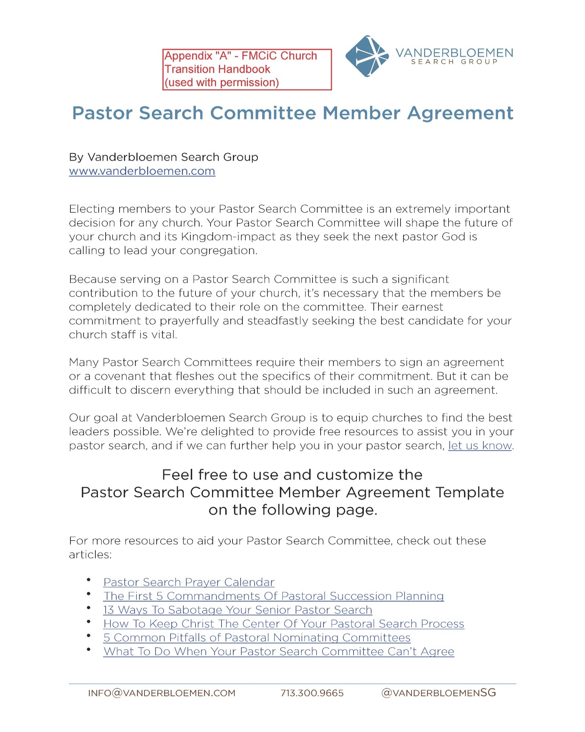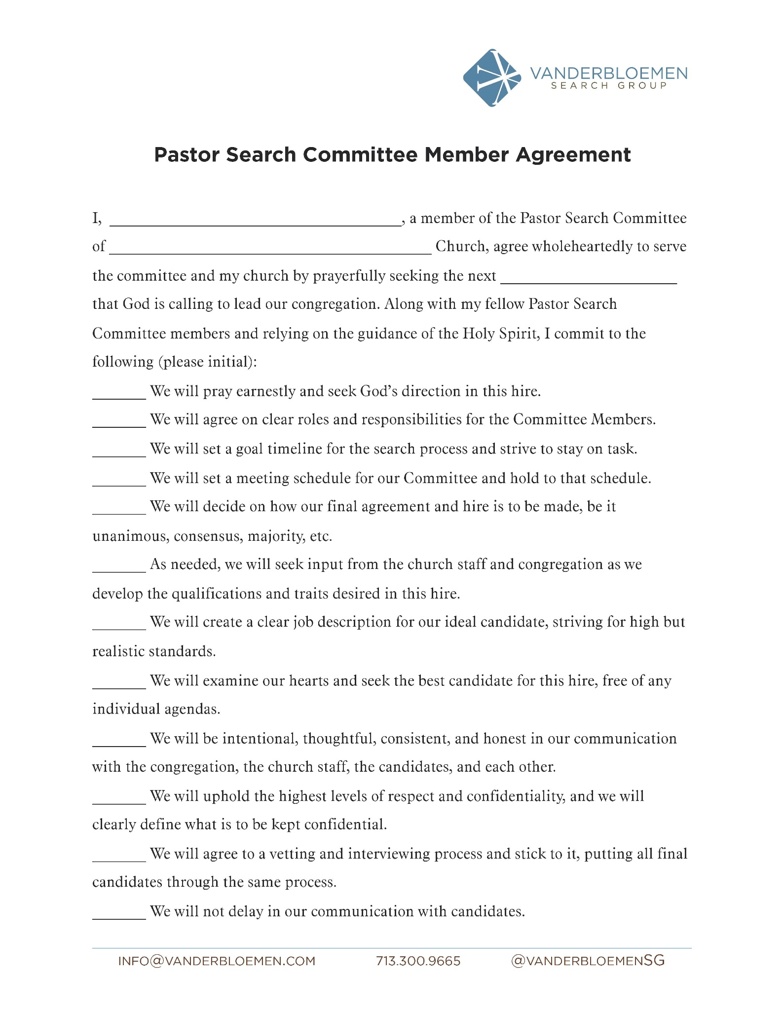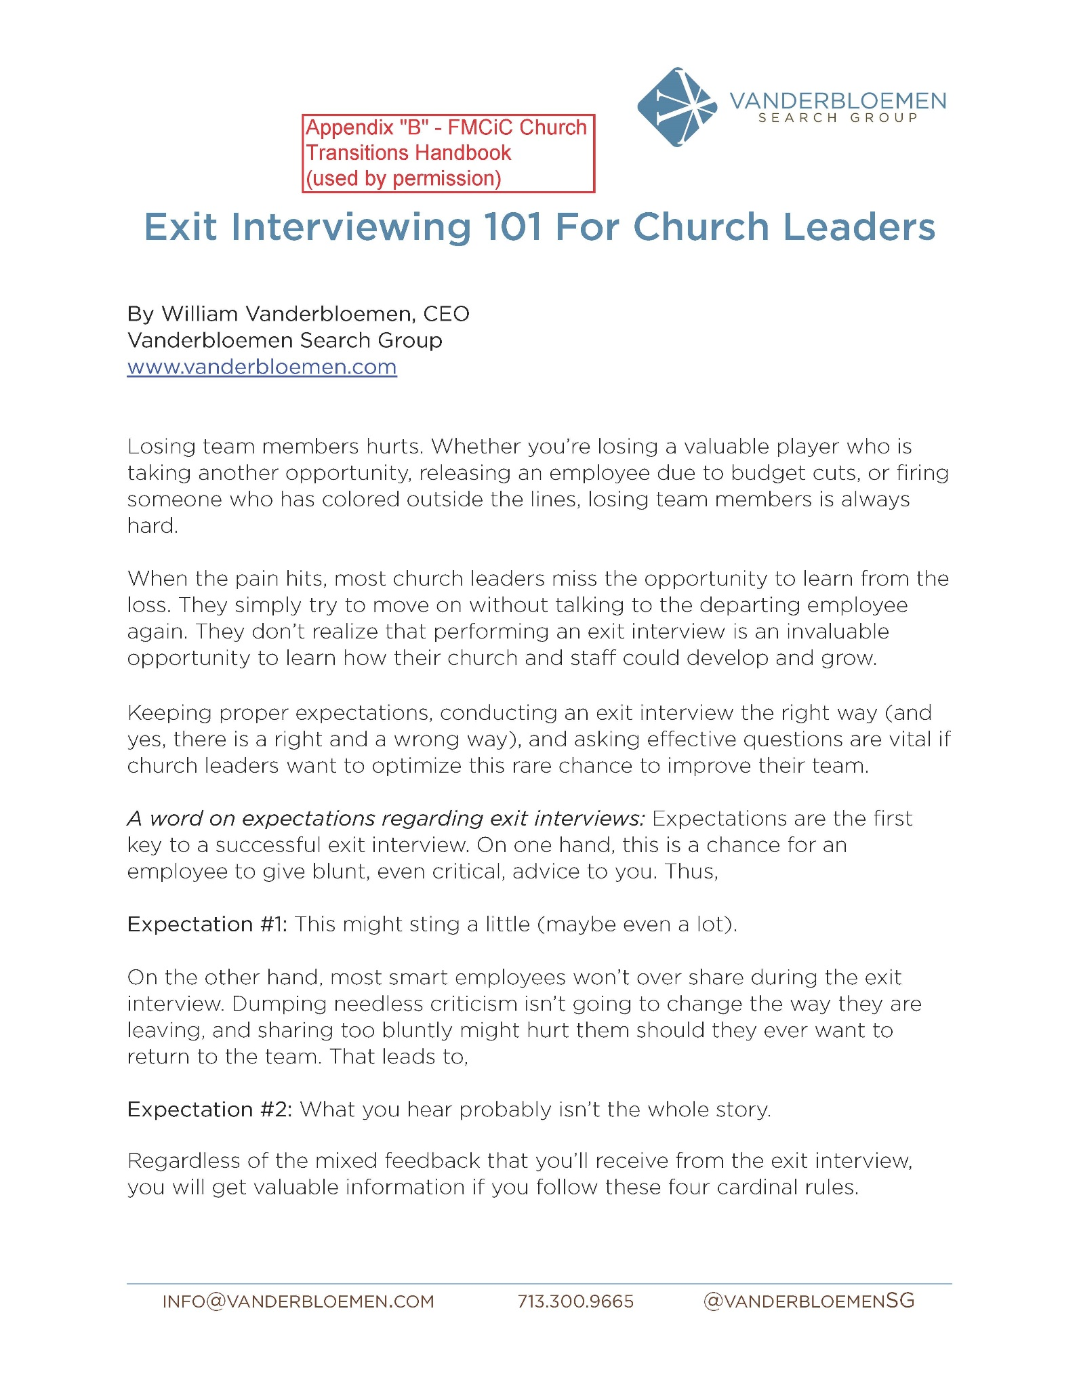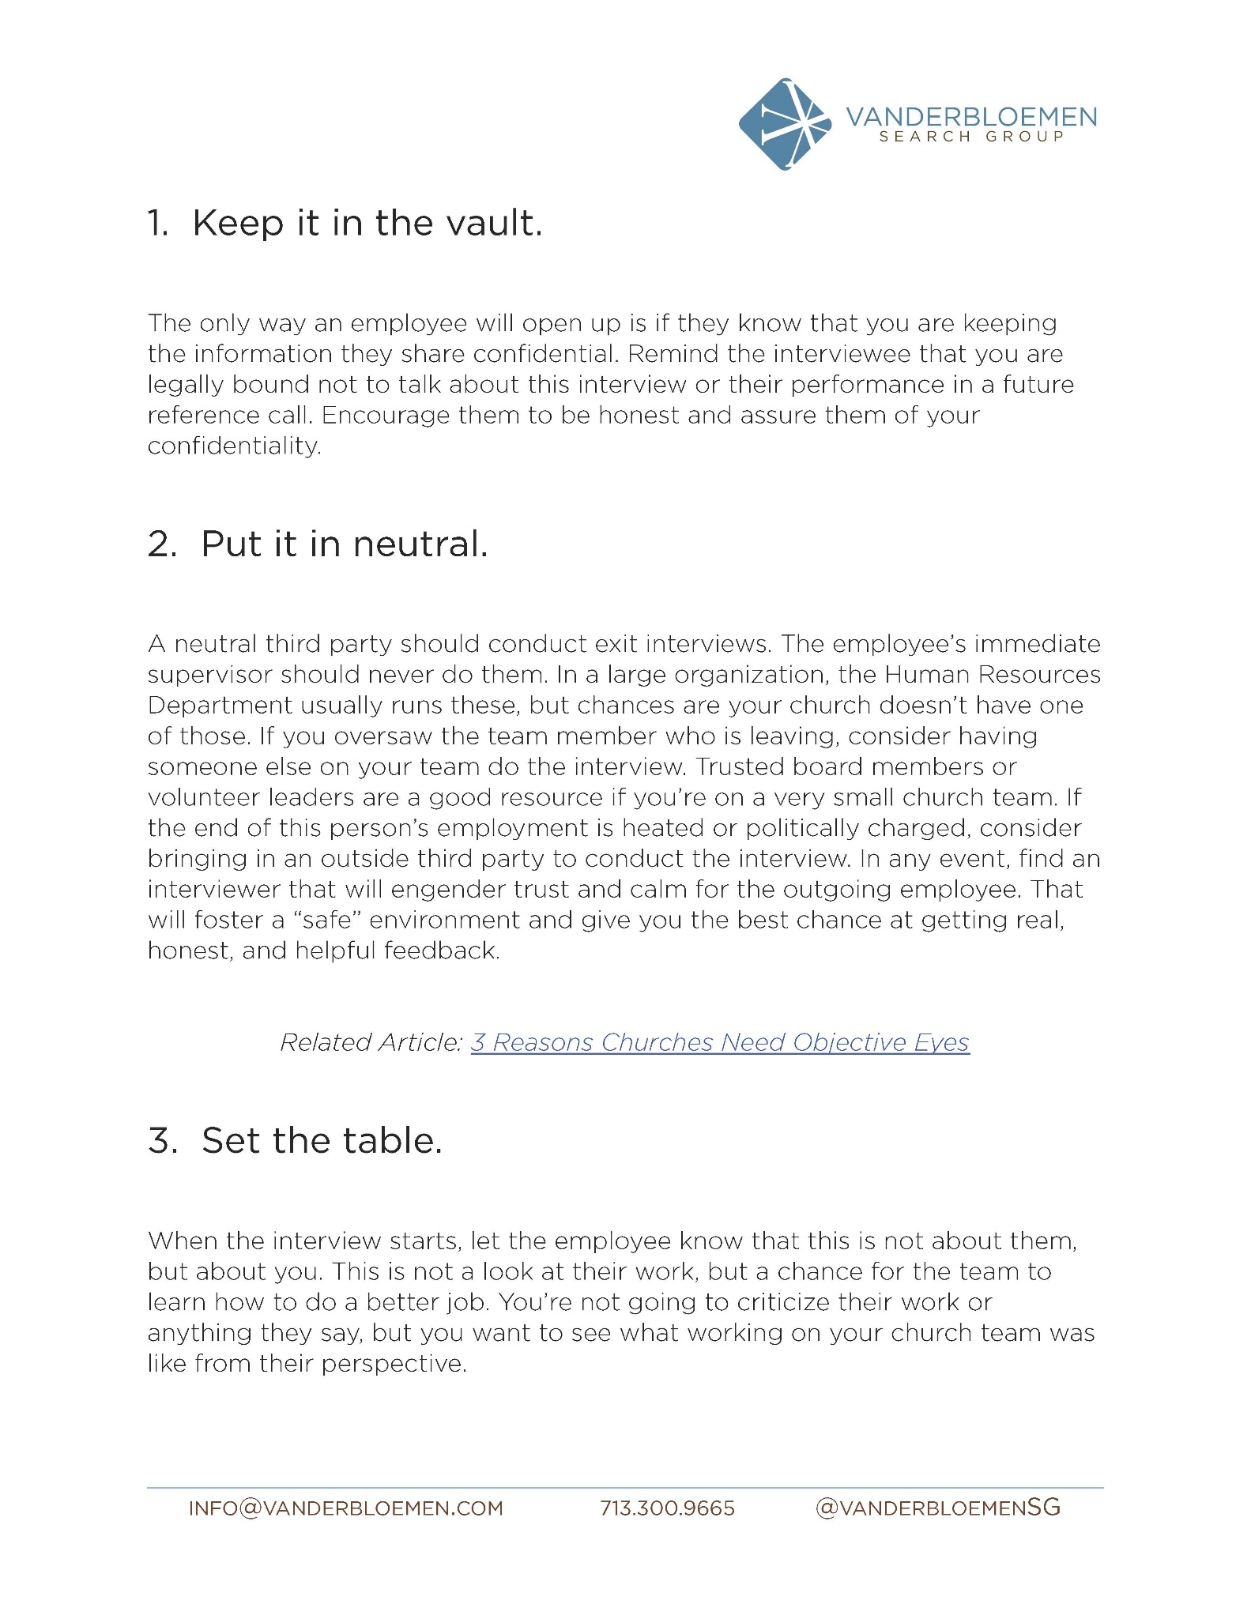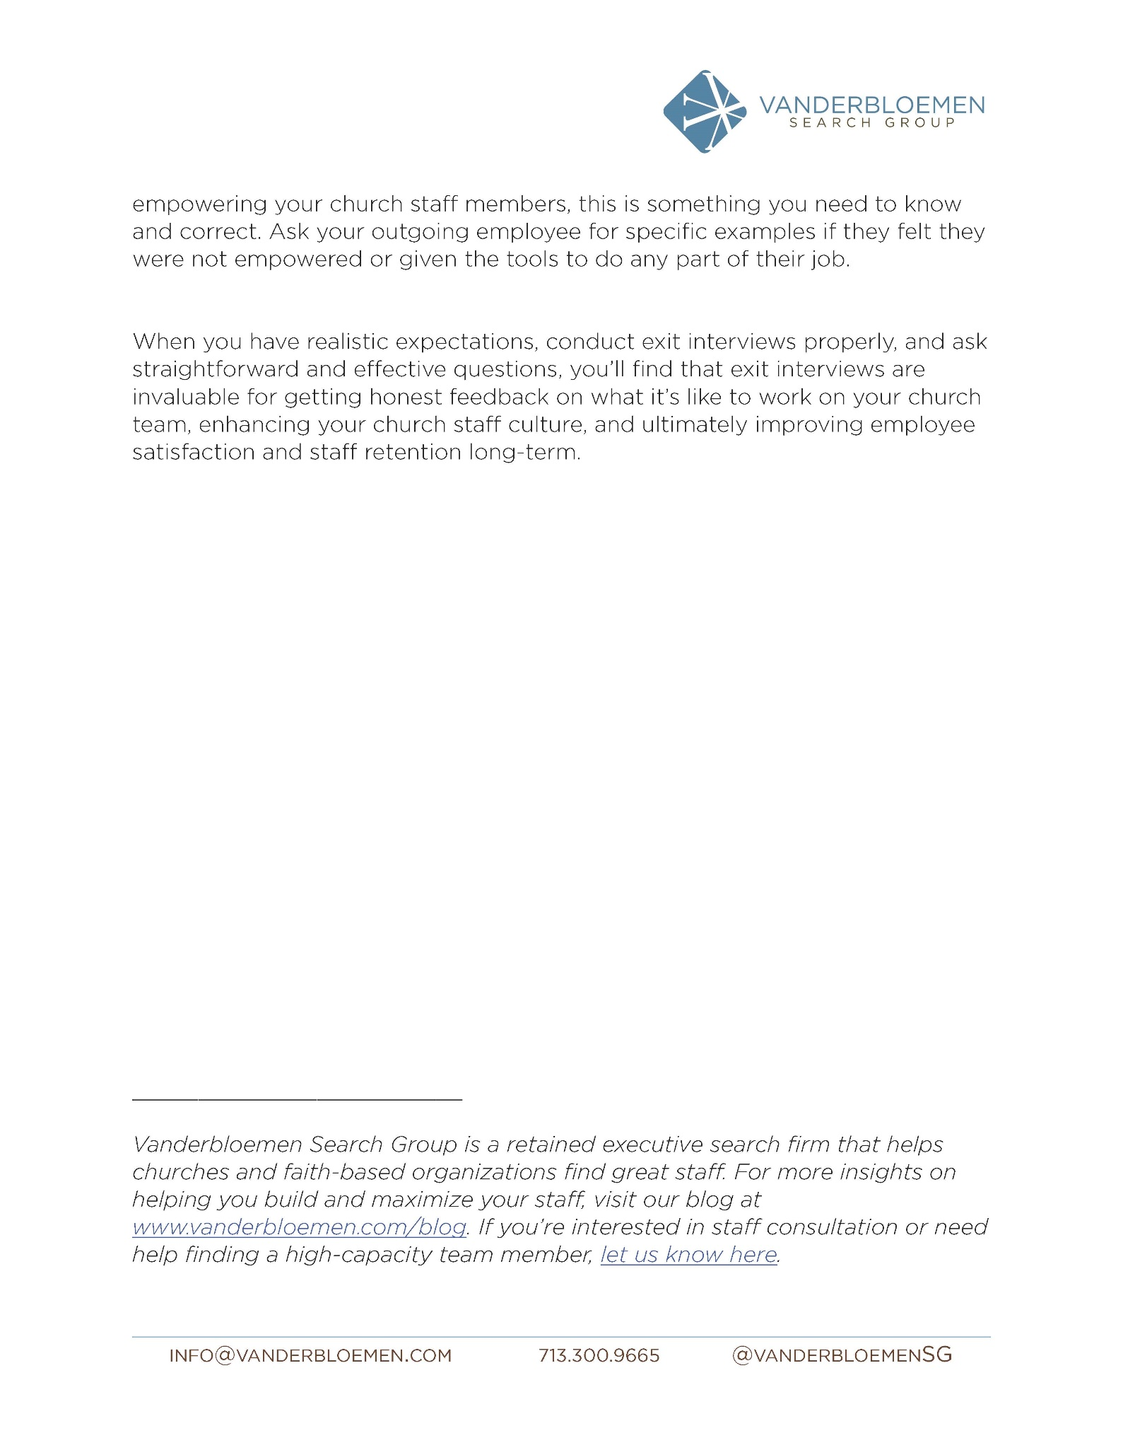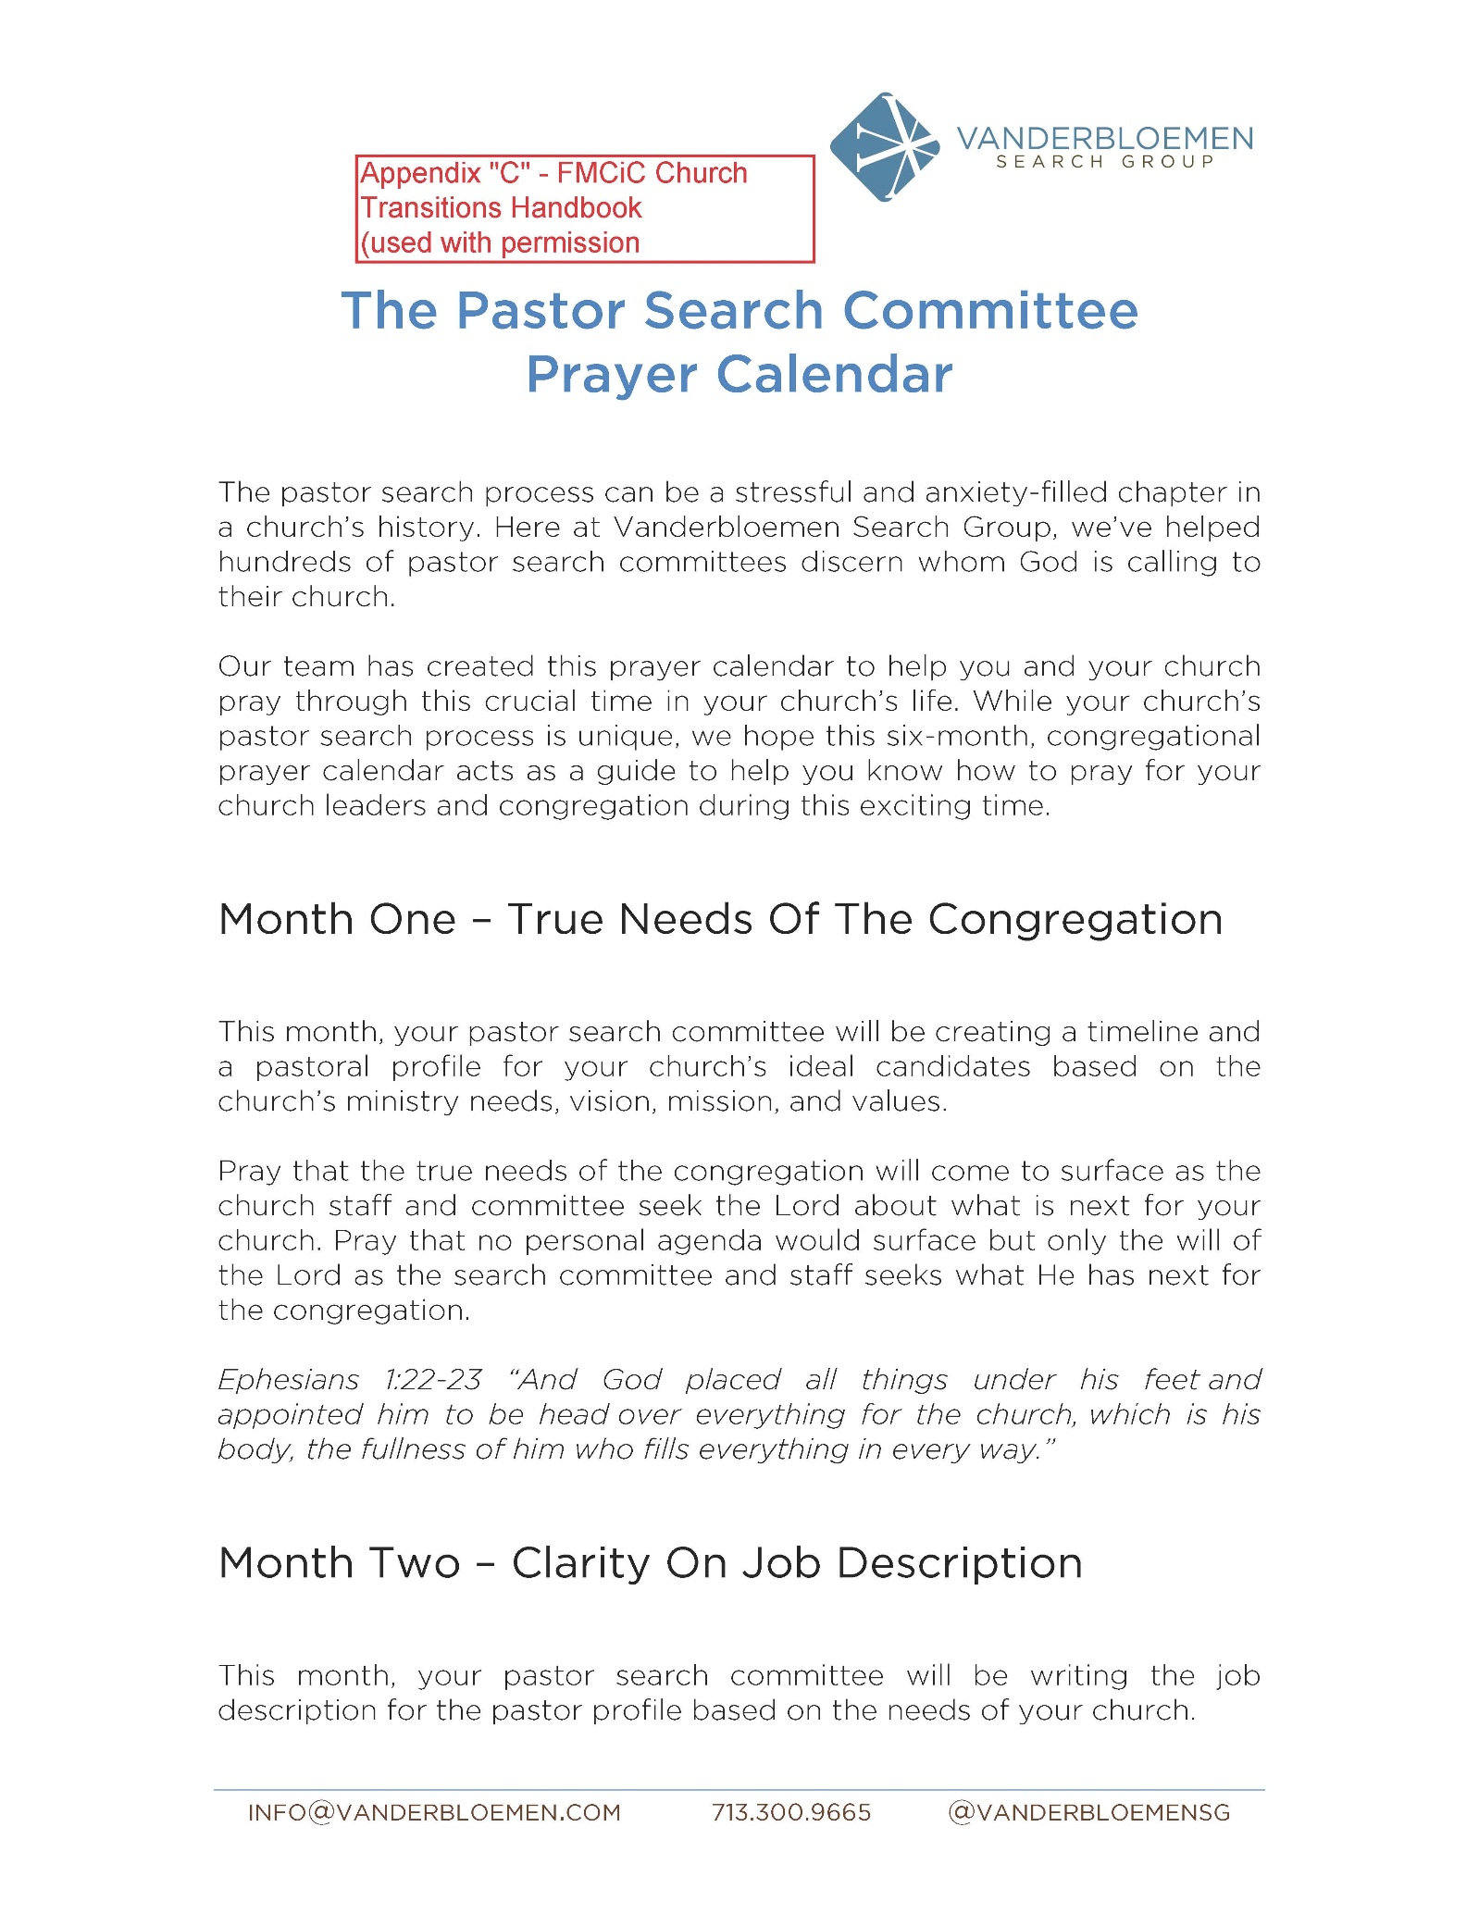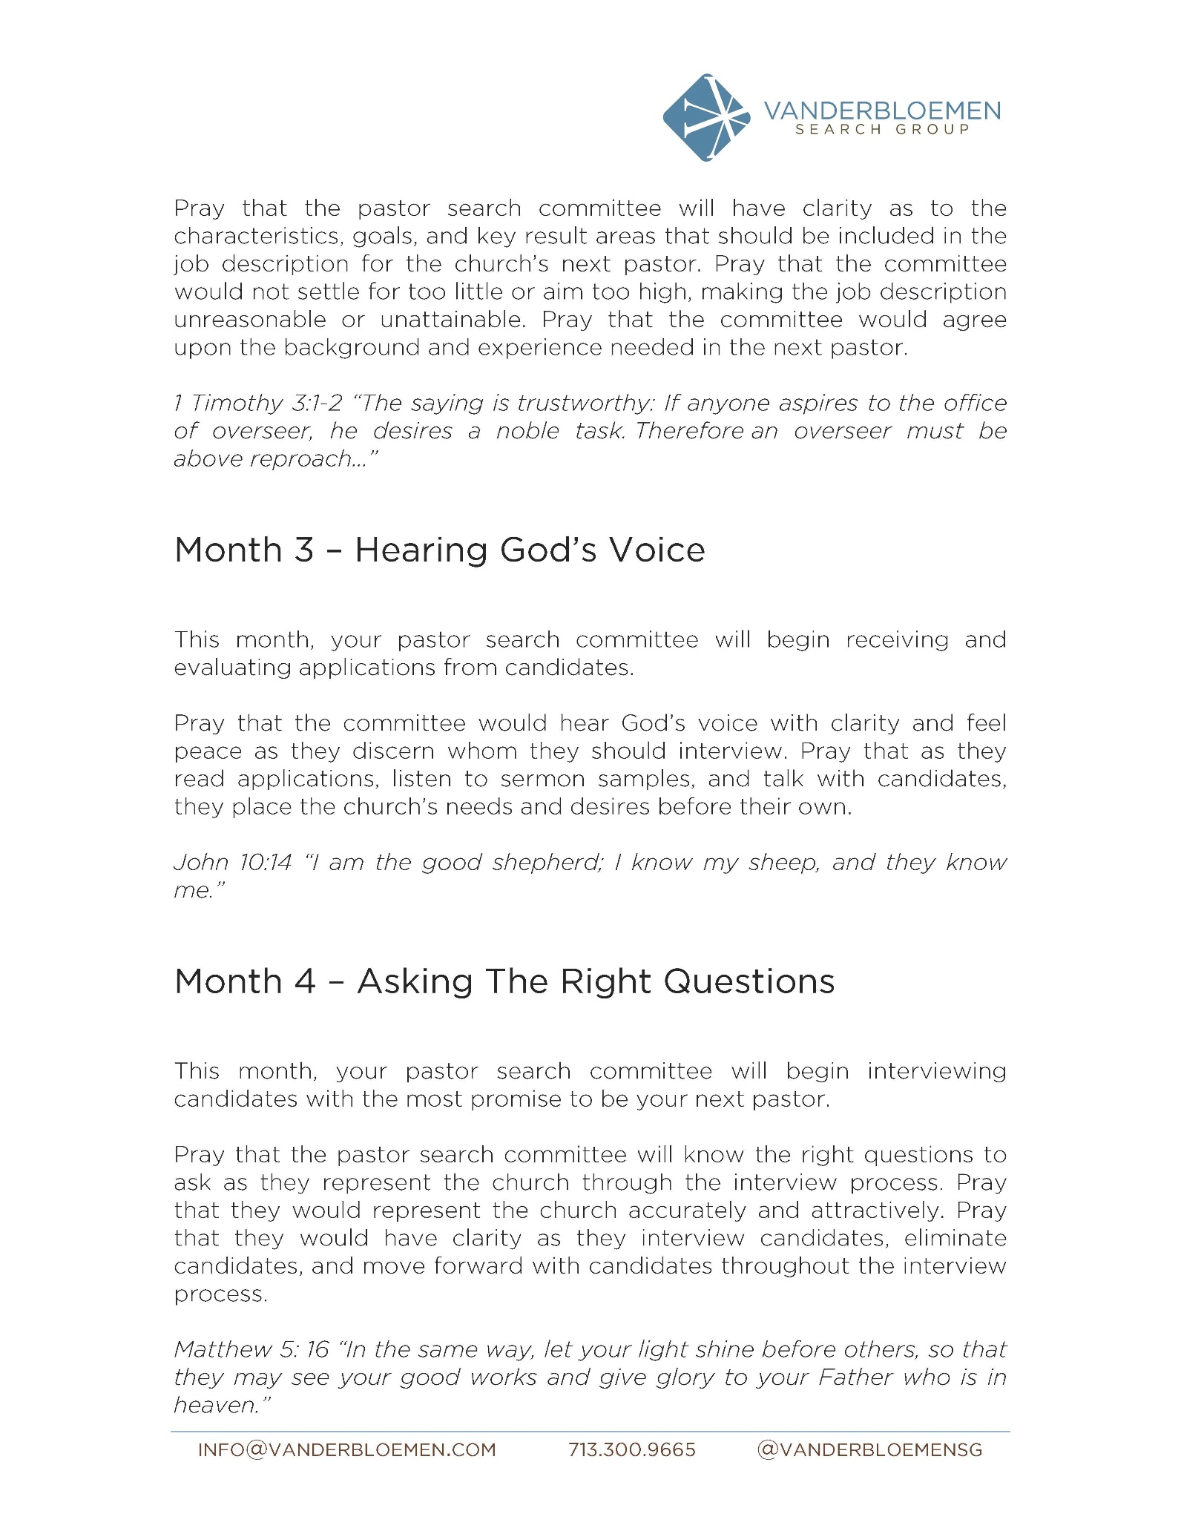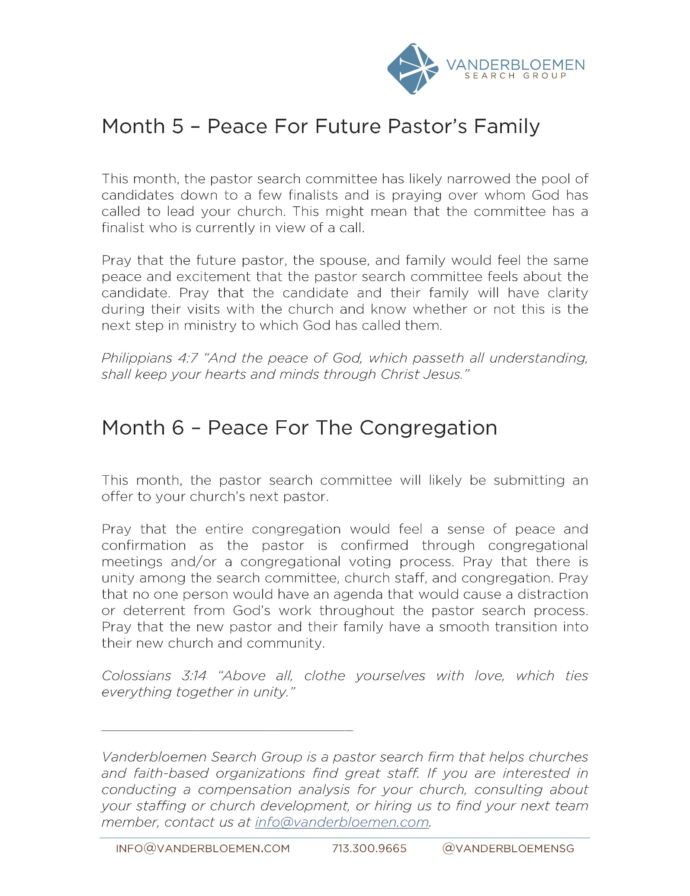

APPENDIX “D” - FMCIC CHURCH TRANSITIONS HANDBOOK

TRANSITION PASTOR JOB DESCRIPTION

Position | Church
Transition Pastor

Name (or Incumbent) | Location
Reports to | Date of last Revision
Network Leader: __________________
The Official Board of _____________________
The Free Methodist Church in Canada

Peers | Team (Ministry Leaders/Staff)
The ___________________Network led by ___________________________________

Position Overview

In a process, empowered and guided by the Holy Spirit, the transition pastor leads the church to grow in health and spiritual renewal. Then the church from this place of health is ready for a new lead pastor, who fits the congregation's vision and mission, to be appointed and employed.

Minimum Education and Experiential Standards
Formal Education | Job Related Experience
 | No experience required | < 1 year | 1 -3 years | 4 - 6 years | 7 - 10 years | 10+ years
No educational requirement
Some High School or equivalent
High School Diploma or equivalent
High School Diploma + job related courses or equivalent
Community College or equivalent
Technical trade
Bachelor’s degree
Master’s degree
Professional Designation (e.g. CA, P. Eng., C.H.R.P., M. Div.)
Doctoral degree
Minimum Past Career Experience:

Preferred Education and Experiential Standards
Formal Education | Job Related Experience
 | No experience required | < 1 year | 1 -3 years | 4 - 6 years | 7 - 10 years | 10+ years
No educational requirement
Some High School or equivalent
High School Diploma or equivalent
High School Diploma + job related courses or equivalent
Community College or equivalent
Technical trade
Bachelor’s degree
Master’s degree
Professional Designation (e.g. CA, P. Eng., C.H.R.P., M. Div.)
Doctoral degree

Ideal Past Career Experience:

The incumbent would possess
- transitional leadership training
- credentialled with the FMCiC
- substantial lead pastoral experience, ideally including previous transition pastor experience

Other important Information about this position:

NOTE: If a transition pastor is a potential candidate for the permanent position, s/he must declare that possibility at the onset, and if s/he decides to apply, s/he cannot continue to be part of the PLTF, but can still help keep the PLTF on track and ensure the congregation remains informed.

RESPONSIBILITIES AND ACTIVITIES

The prioritized major responsibilities, percentage of time, key activities and standards of performance for this position are listed below:

MAJOR RESPONSIBILITIES
(Suggested percentage of time allocated to each area of responsibility)

Major Responsibility Overall Percentage of Time

1. Vision Renewal or Creation 25%
2. Preaching and Communication 25%
3. Pastoral Care 20%
4. Short term Administration 15%
5. Pastoral Search Process 15%

KEY ACTIVITIES

- Major Responsibility: Vision Renewal or Creation
Key Activities | Standard of Performance
- Life Plan Process | - Lead the congregation through Life Plan, as needed  - Ensure results of Life Plan process are incorporated into the new pastor's JD
- Organizational Structural Renewal | - Assess church governance model and adjust as necessary  - Review local church policies and adjust as necessary

2. Major Responsibility: Preaching and Communication
Key Activities | Standard of Performance
- Preaching | - planned messages relevant to people's needs and the transition process  - using other methods (eg. Dwelling in the Word) to bring God’s people together  - involved in facilitating worship
- Communication/  Conversation | - Communicate the FMCiC transitions process  - Ensure the congregation is updated regularly through town hall meetings, reports from the board, reports from the PLTF, etc.  - One-on-one conversations  - Ensure Directors of Church Health and Personnel are updated regularly

3. Major Responsibility: Pastoral Care
Key Activities | Standard of Performance
- Identify transitional issues to be resolved | - using an “Appreciative Inquiry” process and other tools such as church timeline, healing and forgiveness services:  - help the congregation accept the past, face the present reality and decide to move forward
- One on one meetings | - Active listening  - Intentionally initiate conversations
- Responding to crisis needs | - Create a sense of approachability and caring
- Passages of life ministries | - Baptisms, weddings, funerals, etc., as required
- Providing positive and healthy closure | - deal with any unresolved relational and/or structural issues  - facilitate an exit interview with previous pastor, if possible
- Relationship renewal/restoration | - Teach and facilitate conflict resolution and management  - Facilitate intercultural conversations and relationships

4. Major Responsibility: Short -Term Administration
Key Activities | Standard of Performance
- Facilitating leadership teams | - Regular board meetings, staff meetings, ministry team meetings, society meeting  - Ensure effective ministry continues according to current vision and mission

5. Major Responsibility: Pastoral Search Process
Key Activities | Standard of Performance
- Coaching | - Using the Church Transition Handbook, resource the PLTF to create the Church Profile  - Coach the PLTF through the interviewing process  - Ensure regular, effective communication to the congregation

CORE COMPETENCIES
The operationalized core competencies which the incumbent must demonstrate in order to be effective in this position are listed below:

Core Competency | Operationalized Competency  “What does this look like on the job?”
Communications – Spoken and Written | Able to clearly present information through the spoken word; influence or persuade others through oral presentation in positive or negative circumstances; listen well: able to write clearly and effectively present ideas and to document activities; to read and interpret written information
Leadership | Able to influence the actions and opinions of others in a desired direction; to exhibit judgment in leading others to worthwhile objectives.
Decision Making and Problem Solving | Able to take action in solving problems while exhibiting judgment and a realistic understanding of issues; able to use reason, even when dealing with emotional topics.
Reading the System | Able to recognize and use information about organizational climate and key individuals to accomplish legitimate organizational goals; be aware of the importance of timing, politics and group processes in managing change.
Energizing / Interacting | Able to create positive energy (motivation/encouragement) in both individuals and groups. Able to communicate with others in a warm and helpful manner while simultaneously building credibility and rapport.
Organization and Planning | Able to organize or schedule people or tasks; to develop realistic action plans while being sensitive to time constraints and resource availability.
Team Building | Able to work with people in such a manner as to build high morale and group commitments to goals and objectives.

OFFICIAL BOARD APPROVAL

This is to certify that the Official Board of _________________________________ Church has approved the Job Description of Pastor __________________ and will:
- send an electronic copy of the approved Job Description to the Superintendent of Personnel within thirty days of approval.
- recommend that the 360 team participate in the Performance Appraisal training in six to nine months when offered in the area.
- have the Performance Appraisal completed within one year of this Official Board recommendation and send a copy of the results to the Superintendent of Personnel.

Done by order of the Official Board of the _______________________Society of The Free
Methodist Church in Canada at __________________________ this ________ day of_____________, 20____.

________________________________________Pastor

________________________________________Secretary

