SECTION FOUR – THE INTERVIEW PROCESS

PART A – IMPORTANT INFORMATION WHEN RECEIVING RESUMES

Prayer

The reality about the importance of this decision will start to sink in. Seek God’s will.

Confidential process

You now have real resumes from real people. Breaches of confidentiality at this point can have very serious ripple effects in real lives and in congregations of churches.

Confidentiality: It is extremely important that the PLTF hold the names of those who have applied in the strictest confidence. This information cannot be shared with anyone, including the spouses of PLTF members. While this level of confidentiality is necessary for everyone involved, it is particularly important for those candidates who have applied and who are currently serving as pastors under appointment in another Free Methodist church.

Reviewing resumes
The PLTF needs to stay on track by remaining true to the vision, mission, core values, pastoral job description and especially the prioritized core competencies. This will anchor the choice of questions around the official board approved purposes for the church and, more specifically, will guide the chair of the PLTF to aim at the right target.

- Each member of the PLTF should have a copy of the vision, mission, core values, pastoral job description and prioritized core competencies before looking at the resumes.

- Utilize the Candidate Evaluation Template (see Appendix “L”) and customize it to help keep the PLTF focused on identifying the candidate who has the capacity to lead the church.

SECTION FOUR – THE INTERVIEW PROCESS

PART B – CREATING A SHORT-LIST OF CANDIDATES

Communication to the Applicants:
When the Credentialing Coordinator has forwarded the resumes to the PLTF chairperson, all of the applicants are informed that this action has been taken. The applicants will know the date that their resumes, cover letters and any supporting documents are in the hands of the PLTF. It would be very appropriate for the PLTF chairperson, on behalf of the team, to let the applicants know that their applications have been received, and to provide some sense of the timeline with which the PLTF is working, so that the applicants understand when they can expect to be notified as to whether or not they have been short-listed for the position.

Getting resumes to PLTF members before the meeting:

There are three reasons for each PLTF member to review the resumes individually before the PLTF meets together:

- If anyone on the PLTF is related through blood or marriage to any one of the candidates, that member must recuse him/herself immediately from the PLTF unless and until that relative is no longer shortlisted.

- Each member of the PLTF can be in prayer over the applications as well as be thinking about strengths of particular candidates in relation to the vision, mission, core values of the church, and the core competencies the PLTF identified in the profile.

- Each member of the PLTF individually uses the Candidate Evaluation Template (see Appendix “L”) along with the church profile and pastoral job description to aid in this process so that each PLTF member comes to the meeting with his/her thoughts recorded. This will aid greatly in the creation of the short list.

The PLTF needs to discipline itself to look at the resumes through the lenses of the church profile and pastoral job description. Each member individually develops a Candidate Evaluation grid (see template - Appendix “L”) using the church profile and pastoral job description to help create the short-list. The “shortlist” is the applicants who are the closest fit to the profile and job description.

The Director of Leadership Development will meet with the PLTF once the members have had opportunity to prayerfully consider each of the resumes. This will be to review the process, and to answer questions that will arise about the applicants as the short-list is created. Confidentiality must be strictly respected.

A designated person from the PLTF needs to contact those who have not been short-listed. This can be done by a personal telephone call, email or letter mail. The communication needs to include:
- a thank you for that person’s interest in applying for the position
- an explanation that the PLTF met and reviewed all the resumes received
- some comments on strengths that the PLTF identified in the candidate’s resume
- a statement that, after careful consideration the PLTF has decided that this candidate is not the best fit for the position
- closing sentence stating something like, “we pray God’s blessings on your future ministry opportunities.”

SECTION FOUR – THE INTERVIEW PROCESS

PART C – THE FIRST INTERVIEW

CONFIDENTIALITY REMINDER: Only the members of the Pastoral Leadership Task Force (PLTF) should know who has applied and who has been shortlisted. Members of the PLTF - please do not share this information with anyone, including spouses.

Purpose: get to know each short-listed candidate for general fit
Focus of Questions: candidate’s resume, sermon recording, any pre-interview written responses
Outcome: discern if the PLTF should continue with this candidate to the next interview

Before the first interview:
- Request from each short-listed candidate a recent, representative recording of a sermon (i.e. CD, podcast, YouTube, etc.). Send a copy to each PLTF member with instructions to listen to it prior to the first interview.

- Request that each short-listed candidate prepare written answers to the following questions and send them to the PLTF chairperson by email attachment:
      - Please tell us your testimony of how you came to faith in Jesus Christ.
      - Given our church profile and job description, including the key core competencies, tell us why you believe God is calling you to be our next pastor? Please be brief (1-2 pages)
        - Which of our church values resonate with you the most?
        - What parts of the job description are most exciting to you? Which would be the most challenging?

- Create a response sheet for each candidate to include sermon recording notes and interview responses. (see Appendix “M”-Listening Guide For Evaluating Teaching/Sermon Samples.)

- After reviewing all responses together, the PLTF will conduct the first interview.

First Interview:
Telephone/video interview: The nature of the first interview is such that it is fine to have it by telephone or video call (ie Skype). As you set this up, be sure that your technology works well. If the candidate is local, then s/he could be asked to come for a face-to-face first interview.

The PLTF should assign one or two persons who will ask the questions so the others can take notes. Allow others to ask a follow-up, or probe an issue, but mainly use one interviewer. When the interview is being conducted by phone or video conference call, be sure to explain to the candidate what is happening, ie “the PLTF members are here”, “I’ll be leading this first part or asking the questions, etc.”

Our counsel to candidates who are applying while currently serving as pastor at another church is to NOT share with their leadership that they are exploring another appointment until they have been notified by a PLTF that they have been short-listed. For pastors to share this information with their leadership this early in the process would increase questions and anxiety levels at the candidate’s local church for no reason, especially if the PLTF decides not to pursue a particular candidate, or the applicant chooses not to continue in the process. This is another reason why effective communication is necessary.

Questions for First Interview (via telephone/video call):
As this is an employment interview, there are some questions that should not be asked – particularly those of a direct, personal nature. Some pastors include detailed personal information on their resumes, and while the reason behind that is very understandable, that is not what is legally required. The only legally required personal information that has to be on a resume is name and contact information – not marital status, information on spouse, children, etc. Please do not be influenced by more information (that really shouldn’t be there in the first place), and please don’t disregard resumes for what could be perceived as a lack of information. The position that has been posted is the lead pastor position – please keep that and all the work you have done on the profile and job description in the forefront of the selection and interviewing process.

Having written that, spousal/family support of a pastor is also incredibly important. So rather than asking the candidate if s/he is married (again – which is illegal), for how long, what gifts his/her spouse has, how many children, etc., begin with a question along this line: Can you share with us how your family feels about this potential change?

- Work Experience: Asking "best, worst; greatest, least" questions:
From the resume: Ask these questions of their MOST RECENT work/job/assignment, and their SECOND MOST RECENT. You may not have time for further history.
- "At your present work what has been your best experience, what have you enjoyed the most."
- "What would you say has been your worst experience...?"
- "What has been your greatest accomplishment....?"
- "What have you least enjoyed in your work?"
- "What has been your biggest disappointment?
- "What has been your greatest success in your work?"
- "What did you find you did well?"
- "What did you find you really struggled with in your assigned responsibilities?"

- General questions:
- How would you define the role of a pastor?
- What is your normal day off?
- What are your rhythms when it comes to spiritual and self-care, ie days off, practicing spiritual disciples, etc.?
- How do you stay organized?
- Can you share with us how your family feels about this potential change?

- Questions from the Candidate: PLTF asks, “Do you have any questions for us?”

- Concluding the Interview: “Thank you for coming/talking to us. You can expect to hear back from us by_________________________”

At the conclusion of the first interview, the PLTF will discuss the results and make a decision regarding whether to go on with each candidate to the second interview. Those who will not be going on to the second interview will be called or emailed to let them know that the PLTF will no longer be continuing with them and by telling that candidate, “Thank you very much for your time and energy; we pray for God’s clear direction in your life.”

When calling those who are moving on to the second interview, you also need to verify the references they have listed, or get references if they didn’t submit those, and let the candidate know you’ll be contacting those references before the next interview. Also seek permission to contact the candidate’s immediate supervisor if not already listed as a reference.

References:
Verify the references each candidate wants you to contact. Suggest additional references you may want from the candidate who could speak to different aspects of relationship with that candidate, i.e. colleague, supervisor, subordinate, etc., and get permission to contact all references.

If a candidate remains on the short-list after the first interview, and is not currently part of the FMCiC denomination, appropriate conversations and a pre-screening interview will be scheduled in a timely manner by the Credentialing Coordinator in order to ensure the candidate would also be a good fit denominationally.
Checking references:
Checking references is a must for due diligence. (See Appendix “N” and “O” for guidelines on checking references.) The reasons for checking references after the first interview are:

- Reference checks can be time consuming so it’s best to focus that effort on candidates in whom the PLTF are truly interested and believe have the best potential to be a good fit.

- It may be that the PLTF is struggling between two potential applicants to arrive at the third short-listed candidate and would like to contact some references to help in that process. That is fine – but as per number 2 above, both pastors need to be contacted first, apprising them of where they are in the process, so that they can be in communication with their local leadership before anyone from the PLTF contacts a board chair, delegate, assistant pastor, ministry team leader or any other reference from that pastor’s current appointment.

- Two members of the PLTF should be on the call to each reference so that one person can takes notes to aid in clarity.

It is always wise to check the reference of a previous immediate supervisor. If that supervisor is not listed as a reference, permission must be obtained from the candidate first.

SECTION FOUR – THE INTERVIEW PROCESS

PART D – SECOND INTERVIEW

Purpose: in-depth questioning for fit with vision and key core competencies
Focus of Questions: contextual questions on fit with our vision and competencies
Others: let candidate ask questions.

Goal of the interview: Is this the candidate the PLTF wants to invite for on-site visit?

Face to Face interviews: Ideally, where time, distance and costs allow, have face-to-face interviews with all short-listed candidates.

“Past Performance is the best indicator of future performance”….but do not undermine the Holy Spirit’s power to bring about lasting change in us!

These questions start with: “Give me your best example of__________________.” or “Tell us about a time when__________________.”

The purpose of this interview is to probe what the candidate(s) has actually done, not what s/he wishes to do, not what s/he hopes to do, not what s/he feels in their heart ought to be done. The questions are designed to tell what they actually have experience doing.

It is important to note that some candidates will not yet have many years of pastoral experience. Their life skills and track record in related fields will still be a way to verify that they can do what they say they can do. For example: A person who has built a team in a company from “scratch” can likely build a team of ministry leaders. The skill-set transfers. A candidate who has made a vision for a company turn into reality knows how to make a vision for a church become a reality. A candidate without preaching experience can still show if s/he is able to do public speaking and will learn to preach the scriptures.

It is very important that there is consistency in the interviewing process for the short-listed candidates, understanding that if a two-interview process is adopted, that there may be two or perhaps even just one candidate that goes through the second interview. Developing questions ahead of time and utilizing grids will aid in this. It should be decided ahead of time who on the team will ask the questions. It is also prudent to ask one or two members of the task force to take notes during each candidate’s interview(s) for later reference and comparison.

A reminder…..as this is an employment interview, there are some questions that should not be asked – particularly those of a direct, personal nature. Some pastors include detailed personal information on their resumes, and while the reason behind that is very understandable, that is not what is legally required. The only legally required personal information that has to be on a resume is name, address and contact information – not marital status, information on spouse, children, etc. Please do not be influenced by more information (that really shouldn’t be there in the first place) and please don’t disregard resumes for what could be perceived as a lack of information. The position that has been posted is the lead pastor position – please keep that in the forefront of the selection and interviewing process.

Having written that, family support of a pastor is also incredibly important. So rather than asking the candidate if s/he is married (again – which is illegal), for how long, what gifts his/her spouse has, how many children, etc., invite the candidate to bring his/her spouse to this second interview. While the spouse is not applying for the position and isn’t being interviewed, this does provide opportunity for connection with the spouse. Assure the candidate that his/her spouse is only being invited to come as a support for the applicant and not to be interviewed too. The PLTF would simply like to meet the spouse and perhaps get a sense of how the spouse is feeling about this potential move. (Make sure this is consistent for each candidate coming for a second interview.)

Second Interview:
The goal of a contextual type of interviewing is to find out what the pastor’s past behavior was, so that you can predict what his/her future performance will be like. You are not asking questions to determine what s/he would do in a given situation – you are asking questions to determine what s/he in fact did do in the past related to the behavior you are looking for him/her to repeat as your pastor.

You are asking questions that give him/her an opportunity to give you a concrete example of a time when s/he did something that illustrates the behavior you are looking for in a future pastor.

You also want to avoid the use of “closed ended” questions – those that could be answered with a “yes” or “no”. An example of a behavioral question begins with: “Describe a time when you......” That could be followed up with: “What steps did you take to accomplish that?”

Some sample contextual interview questions are provided below. These are samples only, so the PLTF can adapt these questions and add any others that are appropriate.

Leadership of a Vision:
“Tell us about a time when you had an idea or dream of something you wanted to see happen and then made it happen?”
- What was the dream?
- What were the 5 or 6 steps you took to turn that dream into reality?
- Where is that dream at now?
(If a candidate has pastoring experience: “Give us your best example of how you had a dream/idea for your church and you made it happen?)

Team Building:
“How would you describe your leadership and team-building style?”

“How do you develop team members and volunteers?”

“Tell us about a time you developed a team to work with you on a project.”
- Briefly describe the project.
- What did you do to recruit and develop that team?
- Walk us through how you took one of those team members from a brand new member to a fully functioning team player?

Encouraging Honest and Open Communication:
“Tell us about a time when you handled conflict in a ministry or work situation?
- Tell us about the situation and the actions you took to help the people resolve the conflict.
- What was the outcome of that conflict?
- What else have you done to encourage honest and open communication between people?

“Tell us about a time when you had to get people with different viewpoints to the same level of understanding”

“How do you manage conflict on a team?”

Multi-Cultural Leadership:
“Tell us about a time when you worked with people in a multi-cultural situation?”
- What did you do to help those you worked with to grow in their understanding and appreciation for various cultural perspectives?
- How have you demonstrated acceptance and understanding of various cultural groups?

“Tell us about a time you helped a mono-cultural group become more multi-cultural?”

Engagement with the Community:
“Tell us about a time when you engaged in a meaningful way with the community in which you lived and worked?
- How did you do it?
- What were the steps you took to build bridges between felt needs and ministry to meet that need?
- Give us examples of people you have helped to reach out to others in their community.

Small Groups:
“Give us your best example of your participation in a small group.”
- Where did this happen and what was your role in that group?
- What did you learn about small groups and their role in the growth of Christians?

“Tell us about a time when you organized and led a small group.”
- Where did this happen?
- What was the plan?
- What was your first step?
- What did you do next?
- Where is it at now?
- Did you train new leaders?

Evangelism:
“Tell us about a time when you personally saw people come to Christ.”[do not give names]
- What was your first step?
- What did you do next?
- Where is that person/are those people now?

“Tell us about your best example of organizing and deploying the church for evangelistic action.”
- Where did this happen?
- What was the plan?
- What was your first step?
- What did you do next?
- Where is it at now?

Discerning Gifts: discovering, training, deploying people as ministry leaders and team members:
“Give us your best example of a person you helped find their gift for ministry, trained them and then helped them develop as a leader.” [do not give names]
- Where did this happen?
- How did you walk them through discovery, training and deploying?
- What were the steps you took to develop them?
- What did you do to help them discover their gifts and talent and use those in a meaningful way?
- Where is that person serving now?
If any of the concerns about the candidate are for:
- organization of a church,
- transitioning a church from one style of ministry to another,
- how to reach a community,
- abilities with a special cultural or interest group, circumstance, or
- any other issue

…..then create a contextual question specific to the concern. It should start with a question that gets the candidate to describe their PAST EXPERIENCE in that particular area, or in a transferable context. Then have follow-up probes and prompts like the bullets in the above questions.

General questions:
- “What would you say is your greatest strength(s)?”

- “What would you say is the area(s) where you need to develop or grow?”

- “How do you handle stress?”

- “Can you share with us how your family feels about this potential change?”

- “Do you have any other questions for us?”

Financial Package Questions:
- "Before we conclude, can you tell us the financial range that you feel you will need in order to come to our church?"
- If the candidate asks questions about the financial package, you should give an honest answer. "Can you tell me what you are offering? Do you have a range in mind?"
- If the variance is too large, you may decide not proceed further with a candidate.

Concluding the Interview: “Thank you for coming. You can expect to hear back from us by_________________________”

At the conclusion of the second interviews, the PLTF will discuss the results and make a decision about each candidate as to who will move forward to the on-site visit. The PLTF chair or designate will need to call each candidate as soon as possible after the second interview to let him/her know whether or not they have been selected to move on to the on-site visit.

SECTION FOUR – THE INTERVIEW PROCESS

PART E – ON-SITE VISIT

Invite the candidate who most fits your vision and mission, and core competencies to come to the church to preach, enjoy a potluck lunch and meet the congregation. The purpose of the on-site visit is to let the congregation have interaction and opportunity to make comments before the PLTF makes its recommendation to the Bishop. This should include preaching, a congregational lunch, an informal meeting with the Board, staff and other leaders. Someone could also take him/her/them on a tour of the community to take in points of interest.

There will NOT be a society vote on the candidate – although some members of the congregation, depending on their original church background, may ask about this.

Inviting One Candidate or Two?
The question is asked: ‘Should all second interview candidates get an on-site visit?’ The ideal answer is no. As the PLTF prays, discerns and works through the interviewing and the reference checks, the short list should be narrowed to one top candidate, and that candidate alone is invited for the weekend. However, there may be rare times when there are two very strong yet different candidates and the PLTF is divided. It may be, as a step in the PLTF’s discernment process, that both candidates will be invited for different weekends. Both scenarios call for heightened attention to confidentiality as well as process so that the congregation is not in the position of choosing the candidate for the PLTF.

Careful Communication
The PLTF does need to communicate to the congregation about the upcoming on-site visit:

- The week before the on-site visit, announce verbally and in the bulletin that as part of the search process, one of the potential candidates is coming next Sunday to preach, meet with leaders and there will be a potluck lunch. To maintain as much confidentiality as possible, we cannot share the name of the candidate at this time.

- While the PLTF is hopeful, this visit does not automatically mean the candidate will be selected as the next pastor and because of that, everyone needs to be mindful of the need for confidentiality.

- On the Sunday of the visit, inform the congregation that even when they see who the candidate is, they also must maintain confidentiality of the name of the candidate (ie, no posting on social media, websites, etc.) Explain that the on-site visit is one more step in the PLTF’s discernment process. In no way can it be communicated that this is a ‘done deal’ for several reasons:

- The candidate may decide ‘no’ after the weekend.
- The PLTF may decide ‘no’ after the weekend.
- If both decide ‘yes’, there is still the Letter of Understanding (LOU) to be negotiated and signed – what if no agreement can be reached?
- After the LOU is signed, the recommendation still needs to go to the Bishop for the Ministerial Education Guidance and Placement (MEGaP) committee to consider and approve – what if a MEGaP member is privy to information that could affect the outcome of the approval of the appointment?

At the time of the invitation for the on-site visit, the PLTF and the candidate are usually 90% confident that the fit is good. However, there have been cases where the 10% has been a factor, and either the PLTF and/or the candidate have decided AFTER the on-site visit that the fit would not be good.

It is also very rare for the process to be halted during the LOU or MEGaP steps – but it could happen, and has happened, and so we need to allow for even those remote possibilities. It is never considered a ‘done deal’ until every step has been cleared and the letter announcing the appointment is sent from the Bishop to be read to the congregation.

What to Communicate
- Do not put the candidate’s name or other information on the church’s website, or any other form of social media (ie, Facebook, Twitter, etc.). Once the candidate’s name hits any of the social networking media, we have essentially said ‘good-bye’ to confidentiality. We don’t all have to be friends in order to read postings on social media pages. It’s also wise to not leave the candidate’s name on the church’s voicemail.

- Some churches post the weekly sermon on their websites for audio or video download. It is always wise to get permission from any guest first before posting his/her sermon.

- It is also prudent to address the congregation at the close of the worship service with the invited candidate that their ongoing prayers are welcome as the PLTF continues to discern God’s will – and asking the congregation to refrain from speaking about the candidate with other people and instead to direct their conversation to God first, and then to members of the PLTF.

Inviting Two Candidates
As mentioned above, this can be done – on separate weekends, of course! While this isn’t the ideal, there are times when this extra step needs to happen for the PLTF to be in unity when making a final decision.

All of the above applies twice over. The extra risk here is that people can form connections with others very quickly and easily. Having the congregation interact with two candidates means that some will prefer candidate ‘A’ and some will prefer candidate ‘B’ - and so no matter what decision the PLTF makes, not everyone will be happy. The PLTF needs to move carefully so that this step does not undermine the prayer and the rest of the process (resume, references, interviews, etc.) in which they have played a crucial role, but the rest of the congregation has not. It is important to not suggest in any way that there will be an ‘informal vote’ taken by the PLTF.

Let’s work together to make this process as smooth as possible while retaining as much confidentiality as we can. We have had confidentiality leaks that have made the process more difficult than it needed to be. We need to hold these situations and the confidences of others with as much respect and consideration as we would like others to hold our situations and confidences. While some things are and will remain out of our control, let’s do our best to maintain confidentiality in those areas that are under our control.

APPENDIX “L” – CHURCH TRANSITIONS HANDBOOK

Candidate Evaluation Template
For each criteria based on the profile job description, provide a rating from 1 to 10 (where 1 is low and 10 is high). A lot of high ratings would indicate the candidate is a very good fit. Some questions require a comment rather than a rating.

CRITERIA |  | CANDIDATE
 |  | A | B | C | D | E | F | G
Min. Education
Preferred Education
Credentials
Min experience
Preferred Experience
Core Competency (CC) 1
CC 2
CC 3
CC 4
CC 5
CC 6
Major Responsibility (MR) 1
MR 2
MR 3
MR 4
MR 5
MR 6
Spiritual Gifts
SUMMARY
(who seems to be a fit based on resumes and profile?)
OTHER OBSERVATIONS
Candidate Character Observations
Candidate Strengths/
Accomplishments
Candidate growth areas
Areas of Concern?
Do I think this candidate is prepared for this position?
Other thoughts
Do I think God might use this person to lead us at this point in time, to pursue the vision God has given us as a church?

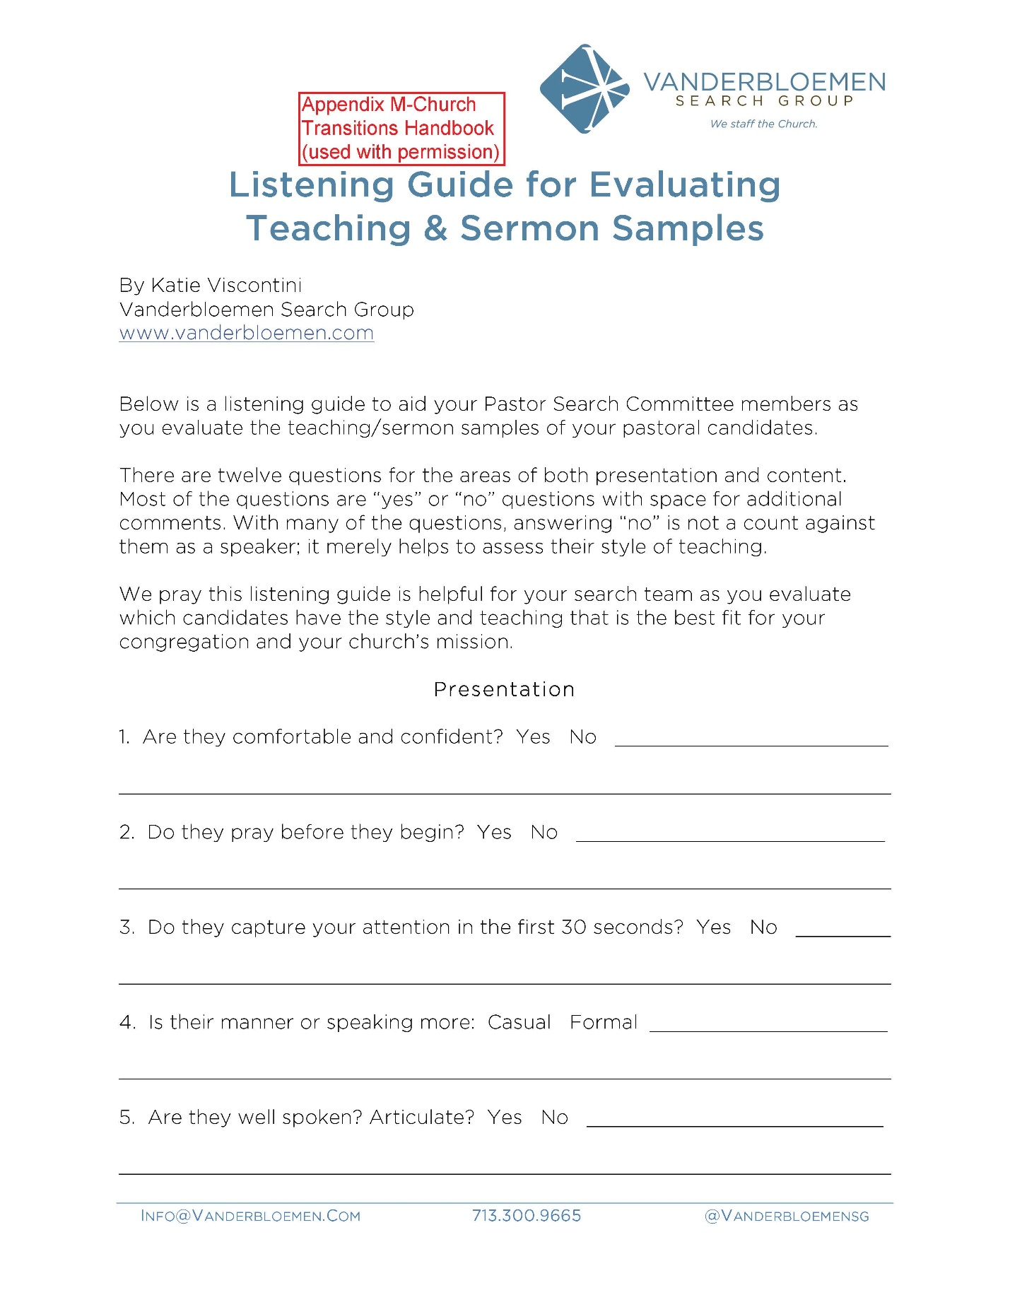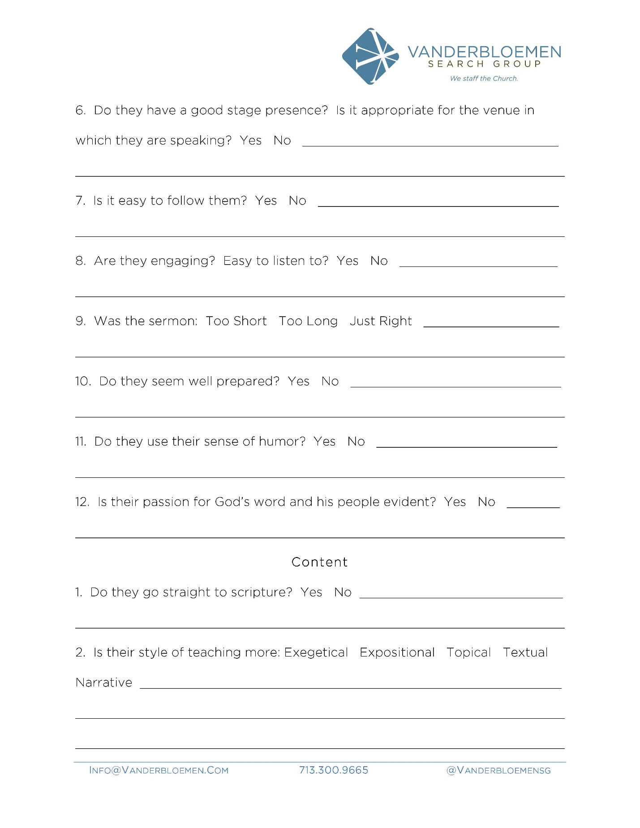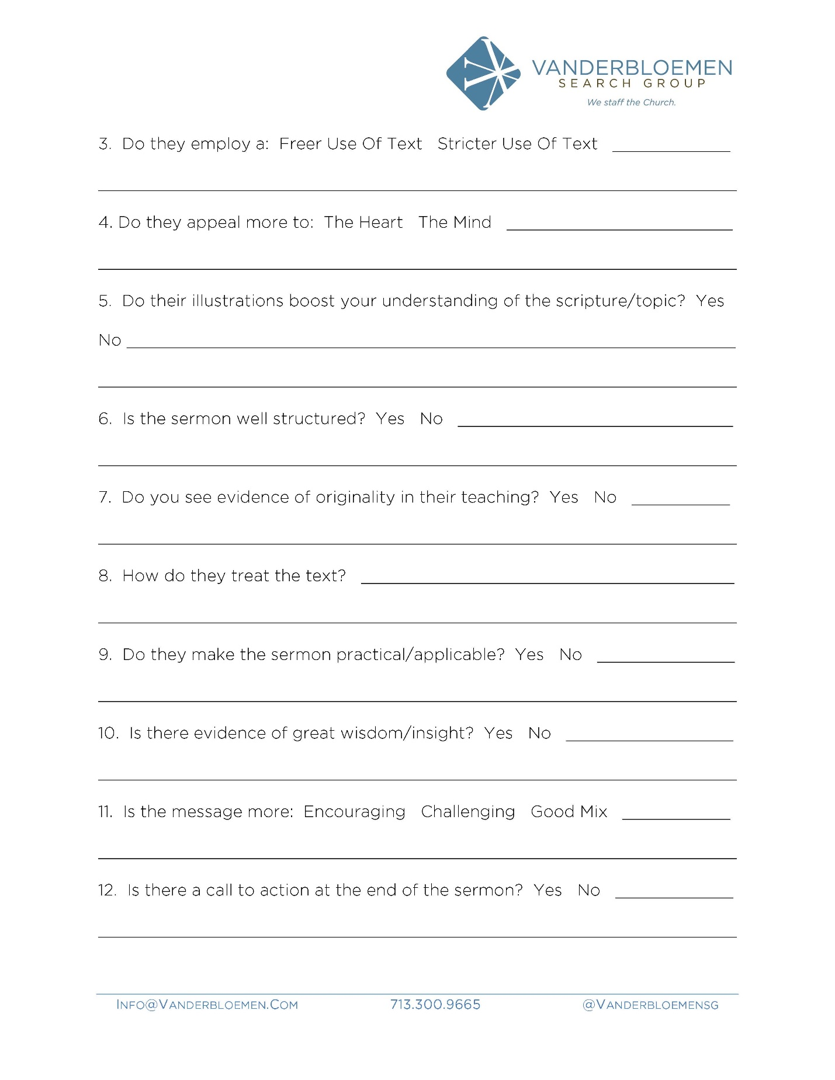

APPENDIX “N” - CHURCH TRANSITIONS HANDBOOK
CHECK CANDIDATE REFERENCES
1. Explain your reason for calling, who suggested his/her name as a reference, and ask for help in making a good choice.

2. It is important to particularly check the reference of the most recent immediate supervisor (Director and/or Bishop).

3. In a telephone conversation you may wish to use some or all of the following questions:

- How well do you know ? (In what relationship?)

- In what areas of ministry does the candidate work best?

- How well does do the things you didn’t mention?

- How would you describe their leadership style?

- What sort of gifts do they bring to the position?

- In what ways has _______________shown the ability to build and lead a team?

- Name one or two areas you would like to see developed or improved?

- What does tend to emphasise in ministry?

- What do you think would be an ideal congregation for ministry for ?

- Is there anything else you think we should know about?

4. After the telephone conversation it is good to reflect on the conversation with these questions:

• How much weight do you give this person’s assessment?

a lot some not much

• What was the level of enthusiasm in support of this candidate?

high moderate low

• Did anything in the conversation surprise you, make you wonder, or arouse some reason of caution in you?

yes no

If yes, what? ______________________________________________________________________

________________________________________________________________________________

• Was there anything you require in a minister in your congregation that was mentioned with reservation or not at all?
________________________________________________________________________________
________________________________________________________________________________

(You may want to double-check these items with other references.)
