

THE

LIFEPLAN

PATH



The Free Methodist Church in Canada

THE LIFEPLAN PATH
Why the “LifePlan” is a process that you should consider!
At regular intervals a congregation needs to take time to prayerfully consider how things are going in its ministry. It needs to consider questions like, “Are there changes that we need to make to become more effective?” “Are there areas we are overlooking where we could be involved in helping and reaching people in our neighbourhood and beyond?”

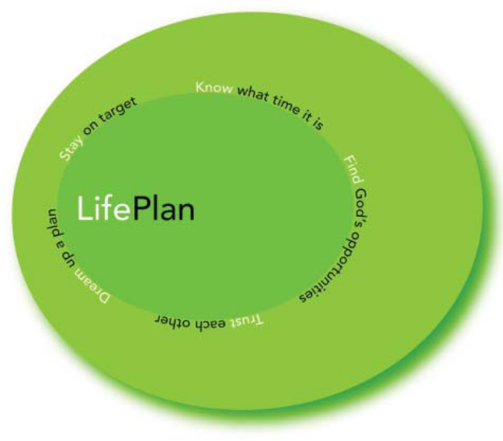
The LifePlan is drawn as a circle. This is because ministry happens in cycles that either spiral upward with encouraging breakthroughs or …sometimes stall, and spiral downward, in decline. Each section within the LifePlan cycle has been carefully designed to try to help congregations see clearly what Jesus presently has in mind for them as a community of his people.

Starting at the top and moving clockwise, here are
the sections.........

1. Know what time it is?
Some basic research will provide a clear picture of what is really happening within our congregation and our neighbourhood.

2. Find God’s opportunities!
As a congregation, set aside time to fast, pray, and reflect on what the Lord is saying to us about what we now know about ourselves and our neighbourhood.

3. Trust each other.
Come together as a community of God’s people to have a conversation about insights that surfaced during the fasting and prayer times. Looking for common themes, decide together which of these themes should receive the most attention and use this as a “sketch” for planning the future.

4. Dream up a plan.
Give the “sketch” to the ministry leaders to develop a more concrete plan that will focus on what has been decided is most important.
Ask the leaders to shape the pastor’s Job Decription so that he/she focuses time, energy and abilities toward following the plan.

5. Stay on target.
3. Trust each other.
Come together as a community of God’s people to have a conversation about insights that surfaced during the fasting and prayer times. Looking for common themes, decide together which of these themes should receive the most attention and use this as a “sketch” for planning the future.
3. Trust each other.
Come together as a community of God’s people to have a conversation about insights that surfaced during the fasting and prayer times. Looking for common themes, decide together which of these themes should receive the most attention and use this as a “sketch” for planning the future.
5. Stay on target.
Compete the cycle well and fully implement the plan. To do this, we need help from others who will encourage us and hold us accountable to stay on target with our plan.
Complete the cycle well and fully implement the plan. To do this, we need help from others who will encourage us and hold us accountable to stay on target with our plan.

6. Rinse and repeat.
After two years, pause to celebrate what God has done and then repeat the cycle again to seek guidance on how to adjust to changes and challenges that have emerged within the congregation and its neighbourhood.
5. Stay on target.
Compete the cycle well and fully implement the plan. To do this, we need help from others who will encourage us and hold us accountable to stay on target with our plan.
5. Stay on target.
Compete the cycle well and fully implement the plan. To do this, we need help from others who will encourage us and hold us accountable to stay on target with our plan.
5. Stay on target.
Compete the cycle well and fully implement the plan. To do this, we need help from others who will encourage us and hold us accountable to stay on target with our plan.
In the pages that follow, you will find more detail on what happens in each section and guidance on how to use various tools and guidelines to help you move around the cycle with a sense of confidence and adventure.
3. Trust each other.
Come together as a community of God’s people to have a conversation about insights that surfaced during the fasting and prayer times. Looking for common themes, decide together which of these themes should receive the most attention and use this as a “sketch” for planning the future.
3. Trust each other.
Come together as a community of God’s people to have a conversation about insights that surfaced during the fasting and prayer times. Looking for common themes, decide together which of these themes should receive the most attention and use this as a “sketch” for planning the future.
4. Dream up a plan.
Give the “sketch” to the ministry leaders to develop a more concrete plan that will focus on what has been decided is most important.
Ask the leaders to shape the pastor's Job Description so that he/she focuses time, energy and abilities toward following the plan.
3. Trust each other.
Come together as a community of God’s people to have a conversation about insights that surfaced during the fasting and prayer times. Looking for common themes, decide together which of these themes should receive the most attention and use this as a “sketch” for planning the future.
5. Stay on target.
Compete the cycle well and fully implement the plan. To do this, we need help from others who will encourage us and hold us accountable to stay on target with our plan.
5. Stay on target.
Compete the cycle well and fully implement the plan. To do this, we need help from others who will encourage us and hold us accountable to stay on target with our plan.
5. Stay on target.
Compete the cycle well and fully implement the plan. To do this, we need help from others who will encourage us and hold us accountable to stay on target with our plan.
6. Rinse and repeat.
After two years, pause to celebrate what God
has done and then repeat the cycle again to seek
guidance on how to adjust to changes and challenges that have emerged within the congregation and its neighbourhood.
5. Stay on target.
CompLete the cycle well and fully implement the plan. To do this, we need help from others who will encourage us and hold us accountable to stay on target with our plan.

Training videos are available on our website: http://fmcic.ca/lifeplan/
Coaching and resources – please contact Marc McAlister at marc.mcalister@fmcic.ca

INDEX

Know What Time It Is? [page 4]

Find God’s Opportunities! [page 5]

Trust Each Other [page 6]

Dream Up a Plan [page 7]

Stay on Target [page 8]

Additional Resources - Notes on “Preparing the Board“ [page 11]
Additional Resources - Notes on “Telling the Congregation” [page 12]
Additional Resources - Sample Sermon [page 12]
Additional Resources – Lifeplan Team [page 15]
Additional Resources – Lifeplan Timeline Planning sheet [page 16]
Appendix 1 - Stats Can info Gathering [page 17]
Additional Resources - Notes on “Gathering Stats/Data” [page 18]
Appendix 2 - Congregational Demographics [page 18]
Appendix 3 - Community Leader’s Survey [page 20]
Appendix 4 - Congregational Survey [page 21]
Appendix 5 - Natural Church Development (NCD) Instructions [page 26]
Additional Resources - Notes on “Doing An NCD Survey“ [page 29]
Appendix 6 - Ministry Map Instructions [page 30]
Additional Resources - Sample “Ministry Map” [page 35]
Additional Resources – Instructions for mapping your congregation [page 36]
Appendix 7 - Instructions For the Writing Team [page 38]
Additional Resources - Sample Writing Team Report [page 39]
Appendix 8 - Guidelines for Soliciting Feedback for the Writing Team [page 42]
Appendix 9 - Instructions for Dreamsession Facilitator [page 43]
Additional Resources - Sample—Developing a Ministry Plan [page 44]



KNOW WHAT TIME IT IS?
1. Make sure the official board thinks that this is a good idea.
- The board and pastor need to be enthusiastic about introducing this process as a normal part of regular church life. One of our pastors has some suggestions about this on page 11.
- The board will need to agree to do a Natural Church Development survey (pages 26-29). It costs money.
2. Talk with the congregation about why the LifePlan is a good idea:
It is recommended that this first congregational presentation of the LifePlan be incorporated into a worship service. The LifePlan, to be effective, needs to become a regular and expected part of the life of your church.
The basic idea: this is about incremental change. To regular help your congregation adjust to the changes in the world around it. The first time around, you’ll get some things rights. A couple years later, you’ll come around it again and get some more things right. Pretty soon you’ll be effectively engaging with the people around your church. One of pastors shares some suggestions on page 12 for telling the congregation.

Goals for presentation in your worship services:
- Preach about healthy, constant and vigilant responses to culture (possible stories might include – Joshua and Caleb, Nehemiah rebuilds the Wall, or the Parable of the Talents). Sample Sermon Notes page 12.
- Introduce the major sections of the process and talk about why each of them is important.
- Give people a clear picture of where we are at. It might a good idea to do some of the research before hand and share it with the congregation (example: Helpful data, Attendance & Church Health Survey)
    - Information from Stats Canada will give a neighbourhood profile (Appendix 1, page 17) and through compiling congregational demographics (see Appendices 1 & 2, pages 17-19) you can have a beginning sketch of yourselves. Let’s take our time and keep this simple.
    - Plan for time at the end of a service to do a congregational survey. As you ask the people to take the survey, explain that “in light of what we have been talking about today, we now want to get a picture of what we value as a congregation”. (see Appendix 4, pages 21-25).

3. Continue to do Research:
We recommend that you do the following research (you can use this section as a check list):
a. NCD Survey (pages 26-29) and/or Congregational Survey (pages 21-25)
NCD measures your church health against 8 Characteristics. The Congregational Survey looks at the values in your church.
b. Community Leader’s Survey (page 20)
Give those that look after your surrounding community the opportunity to speak into the LifePlan of your congregation. We recommend talking to (Police, Mayor, Ward Counsellor, Nurses, Paramedics, Community Organizations, etc…)
c. Ministry Map (pages 30-37)
A Ministry Map analysis shows where the congregation is spending its time and energy AND where the church invests people and money resources in other parts of the nation and the world.
d. Congregational Demographics (pages 18-19)
Some basic demographic information about your church. Collect this information in harmony with the Stat Can data.
e. Stats Can on your neighbourhood/census tract (pages 17-19)
Some basic demographic information about your neighbourhood or census tract.


FIND GOD’S OPPORTUNITIES
As a congregation, set aside time to fast, pray, and reflect on what the Lord is saying to you about what you now know about yourselves and your neighbourhood. What will you focus on during your period of fasting, praying, and reflecting? A report on the data you collected the previous section “Know What Time It Is?” To create this report you’ll need to assemble a Writing Team.

1. Now set up a Writing Team and get them going.
Look for a team of articulate writers, who can sift through all the data gleaned through research and integrate the information into clean ideas. These ideas will create a compelling picture of what has been discovered in the “Know what time it is?” Instructions and samples from other churches are on pages 39-48.


Writing Team: We need to write several descriptions of what time it is that identify implications from what we have learned in the “Know what time it is?” section. Make sure the implications are drawn from the data are collected and shown. Review your first draft with the official board for their input. After you have the board’s input arrange a time to present this to the congregation. What is written must be easily digestible – perhaps only a few pages. When this is presented to the congregation, there may be some who will want more information, so have copies of the raw data available. It’s a good idea to look at the samples on pages 39-48.

2. Time to prepare the congregation for prayer and fasting and reflection.
Ask the people to take your findings and spend some time fasting, praying and thinking about it. This is a rough picture of where we are as a congregation and who’s in the neighbourhood and from it this picture we want to hear from Jesus where he wants us to focus. You might want to present your findings (and some implications) in a Sunday morning message. Your findings should include a prayer guide based on your research. Design some specific questions to help people work and pray through the implications in the descriptions of what time it is. (See the sample on pages 39-48) At the end of the service, invite everyone to a period of prayer, fasting, conversation and feedback on the descriptions of what time it is.

There may be questions (and perhaps even objections) to what the Writing Team
has prepared, so set up a way for soliciting their feedback. (See Appendix 8, page 42.)

Toward the end of the time of fasting and prayer, have the Writing Team process all the feedback that they have received to ensure that the descriptions of what time it is have been adjusted to include the helpful input that has been received. It is important that there is solid agreement as we come to the end of the time of prayer and fasting. Based on this agreement the cycle moves forward to brainstorming. As a congregation you will be answering the question, “What have we seen and what have we heard as we prayed?” “What has God been saying to us, ‘What time is it?’”
TRUST EACH OTHER

Together, as a community of God’s people, have a conversation about the insights that came during your fasting and prayer. You’ll be looking for common themes, and will decide together which of these themes should receive the most attention. Use these themes as a “sketch” for planning the future.

1. Have a congregational Dreamsession about what God has said as you fasted and prayed.


For several weeks in advance, announce to the congregation that you will be facilitating (the pastor or another person in your congregation or an outside person can act as a facilitator) a group conversation where people can share insights that came during their fasting and praying. (There is help for the facilitator in Appendix 9, page 43. If you need outside help email the Director of Church Health at marc.mcalister@fmcic.ca.

Assemble the congregation around tables, in groups of 8-10 and introduce how the brainstorming process will work. Ask what the Holy Spirit has been saying to people as they have been reflecting on the findings. The facilitator will introduce questions like these to help keep the focus in the table conversations:

[a] What does God want us to do in light of what we know about
ourselves, our neighbourhood and beyond?
[b] If God showed up and made this church into the community He wants it to be, what would it look like? How would He have resolved our conflicts?
[c] If, in two years, we brought a documentary crew in to do a story of how God brought us into His future, what do you think they would be taking pictures of?

Recommended: It is best to do the Dreamsession as close as possible to the distribution to the Writing Team Report (within a few weeks). If for some reason your time frame is longer than that, you will need to find a way to remind people of the Writing Team Report so they can be prepared for the Dreamsession.

2. What was discovered after the brainstorming.
The Ministry Centre can email you an excel spreadsheet to help you tabulate the data from the brainstorming. After the brainstorming, the Writing Team will take the top 4-5 priorities that emerged in the brainstorming conversation and create a “sketch” of who the church says it wants to be. Next, present the “sketch” to the congregation at a worship service to check that what the Writing Team came up with is true to what was discovered in the brainstorming. At the end of the service, invite people to suggest changes to what the Writing Team has written and make edits until there is a general consensus.

Now that there is a picture of what is important to the congregation and what the congregation senses God is saying to them. We have what we need to give to the pastor and ministry team leaders to guide their planning. This picture will inform the pastor and ministry team leaders as they develop concrete steps and plans for the future of the church. You can see a sample of this on pages 44-48.

Recommendation: Record and keep all the suggestions that comes from the Dreamsession. There will be good ideas that can be implemented later and ideas that can be implemented along side the priorities.
DREAM UP A PLAN

Give the “sketch” to the ministry leaders and ask them to develop a more concrete plan, that will focus on what has been decided is most important. Ask the leaders to shape or re-shape the pastor’s Job Description so that he/she focuses time, energy and abilities according to the plan.

1. Ministry Plan Developed by Pastor and Leaders of Ministries
With the brainstorming “sketch” in hand to guide you, assess where the church is at and what needs to be adjusted by reviewing the ministry map analysis (Appendix 6, pages 30-37).
Take the results from the ministry map analysis and the priorities that came from the brainstorming work and write a ministry plan. (There is a sample to help you on pages 44-48).
Take the completed plan to the board for their comments. The ministry plan goal should detail short-range (next week-2 yrs); medium-range (3-5 yrs), long-range (5+ yrs).

2. Pastor’s Job Description Adjustments
The board must approve all adjustments to the pastor’s job description.

Because the pastor has an important role in giving leadership in implementing the plan, look at the Major Responsibilities of the pastor’s job description in light of the plan and adjust them to ensure that the pastor is clear about his/her role.

Put the Plan in motion and after one year, do a formal Performance Appraisal for the pastor and make job description adjustments in light of the performance appraisal. (There is help to do the formal Performance Appraisal from the Director of Personnel’s office (susan.deplanche@fmcic.ca). At the end of year two into the ministry plan, schedule an annual review of the pastor’s performance and update the pastor’s job description as things are accomplished. Notes on the performance appraisal and the informal review are to be sent to the Director of Personnel’s office by the delegate.




The next step is to complete the cycle well and fully implement our plan. To do this, you’ll need to stay on target. You’ll need help from others who will encourage you and hold you accountable to the plan you have created.

1. Implementing the Plan:
Commit to build and live in the LifePlan matrix of accountability and encouragement. That will include the following relationships:
Leaders of Ministries to Pastor
The Leaders of the various ministries will give regular progress reports to the pastor and receive encouragement back.
Pastor to Board
The pastor gives regular progress reports to the board and receives encouragement back.
- At the end of one year, the board assesses the progress that the ministry teams have made on the ministry plan and schedules the pastor’s performance appraisal and feedback session.
- At the end of the second year, the Board does a second progress assessment and uses this information to prepare a report to the congregation - celebrating what has been achieved and owning the challenges that continue. The annual pastor’s performance appraisal will also need to be scheduled.
Board to Congregation
The board/pastor plan regular progress reports to the congregation (through formal Society meeting reports and informally through newsletters, testimonies in worship services etc...).

When communicating changes on the implementation of ideas refer people back to the Dreamsession (e.g., “we said this, so we are doing this”)

Pastor to the Network
- During the network meeting’s “What’s going on?” time, the pastor reports on progress and challenges with their church’s LifePlan.
- During the “What’s ongoing?” time, the pastor shares with the network what goal(s) will be accomplished by the next network meeting.
- The Network Leader and the Director of Church Health each have a copy of the church’s LifePlan (Final Writing Team Report; NCD results; copy of Congregational Survey
Pastor to Accountability Partner and to Network Coaching Partner

To help maintain focus, the pastor checks in between network meetings with his/her accountability partner and network coaching partner to be accountable and to receive feedback and encouragement.
Network Leader Mentors to Network Leaders
During coaching times, the Network Leaders and their
Mentor review the progress of a network’s churches and
discuss ways to help each pastor to resource their local church leaders.

STAY ON TARGET … (CONT’D)

2. Rinse & Repeat - Renew the LifePlan after 2 years

Now that you’ve been around the LifePlan cycle one time, you have an idea of how the process works and how you can build on what you accomplished in the last cycle. Because things can change both inside your congregation and in your neighbourhood and you want to stay alert to what is happening you need to once again ask, “What time is it?”

To do this, you need to:
A. Renew information
Update the Stats Canada/Congregational Demographics (Appendix 1 and 2, 17-19)
Revise the congregational survey with additional sections evaluating
“Did we do it?” and “What didn’t we do?”
Update the NCD picture, and the Ministry Map. (Appendix 5 and 6, pages 26-37)
B. Give the new collated picture to the congregation and celebrate what has been accomplished as a basis for faith for the future…
C. Continue with the cycle..............
STAY ON CONT’D]

Suggestion: If after 2 years you are still in the implementation stage and you feel like it is too early to do the whole Lifeplan again, consider doing a mid-point check-in (e.g., NCD, The Journey Discipleship Survey, or Church Health Survey). Then after 4 years it will be time to redo the Lifeplan. Ongoing coaching and resource ideas are available through Marc McAlister, Director of Church Health, marc.mcalister@fmcic.ca

ADDITIONAL

RESOURCES,
SAMPLES AND

APPENDICES

KNOW WHAT TIME IT IS?

Additional Resources - NOTES ON “Preparing the Board”

One of the reasons I was excited about the LifePlan cycle is because our board went through the JDPAS process 2 years ago, and had committed to revisiting the whole “vision/mission THING” again 2 years later. Since I’m new on staff, I’m all about continuity with the past (at least for a while!), and this was an opportunity to bring a revised and much improved version of the JDPAS on stream.
So, unlike many other places, the ground had already been laid for us to introduce LifePlan. One of the main critiques our leadership had given about the JDPAS process was that it didn’t involve the whole church. LifePlan is all about getting everyone involved - a huge plus for us.
Thus, people were on board with the process. What they weren’t so sure about was the timing. With a new senior pastor, and expecting to hire new staff, was this the right time to add more stuff to do? To respond to that concern, I calendarized each step of the process, and showed them how the majority of the “extra” work could be done by using the existing leadership structure or Board, Staff & Ministry TEAM leaders. This seemed to help.

The time feels right for us to be diving in right now - people are excited about the new things that are going on, I’m having fun, and we’re ready for a new dream!

So at our Board meeting in January, the board approved the timetable & the concept of Lifeplan all at the same time! We’re off!

KNOW WHAT TIME IT IS?

Additional Resources—NOTES ON “Telling the Congregation”
We decided to go with a 2-Sunday approach, based on the recent past of this church.
Sunday 1 was a look back, walking through the tough times, naming the tough times, and putting God’s perspective on the fruit that has come out of those tough times. We walked through the path of Romans 5:3-5, seeing how God brings good things out of suffering, and then celebrating the accomplishments of the past 2 years. I walked through the goals that the JDPAS team had set, and explained our progress. We watched an exciting video about our children’s ministry and then took communion as a way of bringing closure to the past, and setting the stage to dream about the future.
Sunday 2 described the process individuals go through to find their purpose in life. I preached from Luke 19:11- and talked about the 5 questions we need to answer in order to hear “well done”. Then I walked the people through those 5 questions as it related to the Lifeplan process. We ended the service taking communion and dreaming about both the immediate future and the “wedding feast” at the end of it all. The service ended on SUCH a high note, it was an incredible anti-climax to have people sit down & fill out the survey! So I mocked it. ;-) I’ve put my sketchy sermon notes for this message on another child page.
The energy level in this place is sky-high right now. I’m having trouble keeping up. Wow.
On a completely different topic, all of the pastoral staff are noticing that the level of spiritual attack has risen exponentially. We are both getting HAMMERED with discouraging thoughts, temptations, and fears. The enemy makes me so mad sometimes – he always hits us where we’re weakest. I would recommend getting equipped and dealing with your weak spots before you go into this process.
Additional Resources - SAMPLE SERMON — “LifePlan Sunday” Sermon Notes
Intro – It’s report card time right now and I went with my son to talk with his teacher. We talked about strengths and weaknesses, and set some goals for the coming months. That night (bad pizza or something!) I had a dream that I was at my 20 year high school reunion – MANY years off, I assure you! I was sitting across from my toughest English teacher – the one who drove us to be our best by being really tough, but really fair. She was asking me what I had done with the past 20 years of my life. And then she asked me about the rest of my life. I woke up with her voice ringing in my ears, “Do you have a PLAN Jay?”
At different times in our lives, each of us faces times where we have to give an account of what we’ve done to justify taking up space & using air. Fortunately, there are several places in the Bible that help us deal with this question and discover some things about why we exist. Tell the story of Luke 19:11 – wealthy businessman going to become a KING overseas, called 3 of his employees together. Gave them $150,000 each – “put this $ to work until I get back”. Became king, said, so show me the $ - one earned $150K, (10 cities) the next, $75K, (5 cities) the final one had hid it in his mattress – fearful. Oh – you think that’s what I am? You’re afraid of me are you? Then why didn’t your fear at least motivate you to put the $ in the bank!!! You’re fired. And those people who didn’t want me king – the penalty for treason is still death. Deal with it. This story contains the keys to understanding why you are on this earth, and what you can do with what you’ve been given!
1. Whom do you serve?
“He called ten of HIS servants”
[a] Jesus is saying that like this king, He is tough but fair, and that there are many in this world who do not want Him to be their king – which will have major consequences in the end.

KNOW WHAT TIME IT IS?

[b] Let’s be clear about something – we are all born into a kingdom ruled by someone, but it’s not God. Our rulers by default are King Satan and Prince Self. We can only get out of their kingdom by being rescued. Let me be clear on this again – you can only get out of the kingdom of darkness by being rescued. You cannot work to earn a passport, you cannot strive to be good enough to cross the border. Only refugees who plead for mercy are rescued by King Jesus.
[c] Not only is it important to serve the right king, storing up what we’ve been given is not an option.
1) The King will come back someday & demand an account (we’ve been given all the resources of heaven - is it the best we can do to barely drag ourselves into the afterlife? NOT!);
2) Living in fear of losing the gifts, or having them stolen/rot, etc is not a great way to live either;
3) We are commanded to risk and make the effort, not to succeed each time.
2. What has the King given you?
“He gave them 10 minas” – 1 minas = 3 mo’s wages. $150,000!!!
[a] Who are you? Questionnaire from ladies night.
[b] Leaping off into God’s dream/plan for us, must be done off of the solid ground of the truth of how much He has given us. You can’t leap off of clouds, no matter what the cartoons tell you – you plummet through clouds, with a sudden death-causing stop at the bottom. Reality is, People are given different gifts, talents & resources – that’s the way it is. We are not all capable of anything – we are capable of what God has made us capable of. He will not demand, “Why were you not more like Apostle Peter, John Wesley or Pastor Jay, He will ask why were you not true to who I made YOU?” Base your dreams in the REALITY of who God made you, not in your fantasies or feelings of obligation. I’ve spent the past 7 years trying to learn the truth about myself – it’s not fun, nor is it easy, but you find out good things too. You need people around you who will tell you the truth about who you are & what you can do. We don’t see ourselves clearly!
[c] Do you know what you have? Take Base 3 contact Gwen Wright at ….
3. What opportunities surround you?
[a] Do you know what’s out there? Don’t despise the day of small things. Start small & work up. Now that you know who you are, look around & see where your passions & gifts match the needs around you.
4. What has the King told you to do?
“put this money to work”
[a] Spend some serious time OVER time talking with & listening to the Master about how your stuff & the world’s stuff come together.
5. What are you actually doing?
“sir, your mina has earned…”
[a] Start taking steps! Otherwise we’re still hiding that $ in the cloth. Now again, our church is working hard to be a good example of these principles. Many people would think of church as an organization that just IS, it’s always been around, it always be here, and that nothing should change over the years. We see in the Bible that a church is a group of people who have been given resources to USE, to INVEST, to BUILD with, to GO SOMEWHERE. We’re using an FM tool called LIFEPLAN that helps us work through these important questions. (logo on screen)



1. Whom do we serve? Where is this church coming from?
[a] We serve Jesus Christ wholeheartedly. We follow the Bible – all of it, despite the struggle to understand, improving every aspect of a person’s life & helping them act like Jesus in every part of their lives. Let’s get that straight. We’re not a social club where everything is up for grabs. We believe in grace – that none of us deserves to be here. We believe in gratitude FOR that grace which means our lives ought to change once we’re welcomed in. We believe in love which means we help each other get better. We believe in telling the truth, even when it’s sometime uncomfortable because we LOVE EACH OTHER.
2. Do we know our gifts?
[a] We are taking not of what’s going on in our community through demographic studies & interviews with community leaders. [b] We are taking stock of what God has given us through the making a ministry map, the NCD survey, a congregational survey (you will be asked to fill one out after the service)
3. Have we dreamed a dream?
[a] Over the summer, a writing team is going to wrestle with the data to see what things stand out & to give us some good questions to wrestle with as a congregation.
[b] Come September, we will be giving you those questions & challenging you to spend some time in prayer & fasting to wrestle with the questions &hear from God about the future of our church
[c] In October, we will get together as an entire congregation and dream together!
4. Have you made a plan?
[a] After our dream session, we will put the writing team back to work to compile the most important things that came out. The Board, Pastoral Staff & Ministry Team leaders will take that and build a plan to work towards those dreams!

Doesn’t that sound exciting? The painful part of this both as a church & as people is the beginning. We HAVE to start based in the reality of who we REALLY are. How many talents has God given each of us? What resources do we have at our disposal? How have we been using them up till now? I have made it an important priority at the beginning of my ministry here to love you folks enough to tell you the truth, even when it’s tough – I love you that much. This part of the journey is no exception – we must face the truth of who we are as a church so that God will be free to multiply what we HAVE & bless who we ARE. And again, this is where communion comes in.
We come to communion acknowledging 2 things: the reality of who we are – unworthy, selfish, broken, shameful people who don’t deserve to be here; but we ALSO acknowledge the unimaginable gift of love & mercy that God gives us in His Son Jesus, in His death for us on the cross, and in the amazing destiny that waits for us at the end of it all! Communion gives us incredible hope for the future because it points us to Revelation 19:6-9.
If you wish to ask for mercy from the King of Kings and serve Him, looking forward to the future He has for you & His church, anticipating the wedding supper of the Lamb, come and receive communion this morning.

The LifePlan Team

Overview
A LifePlan Team will coordinate and implement the LIFE PLAN PROCESS. This is a five phase discernment process to help congregations make healthy decisions about what the Lord Jesus has in mind for it at this time in its history. The Team (4-7 members) will meet every 2 to 4 weeks - depending on where they are in the process. The process will take 4 to 6 months and the step by step work of the team is guided by a LifePlan Manual provided by The Free Methodist Church in Canada.
Team members are appointed by the Official Board and all need to have:
- A sense of God’s call to participate on this
Team and God given excitement about this
ministry
- A desire to be used by God in the area of Research or Writing with skill/ability that would enable you to make contribution to this Team
- The time and energy to serve faithfully

Key Responsibilities:
- TEAM LEADER
- Will coordinate and facilitate the ministry of the TEAM
- Will keep the process on schedule (see timeline below)
- Will communicate regularly with the Board and congregation on what’s happening
- Gifts/Skills required: leadership, organization, ability to affirm and encourage

- RECORDING SECRETARY
- Will keep a clear and concise record of the work of the Team
- Gifts/Skills required: Computer skills, capacity for details

- COORDINATOR OF RESEARCH
- Will recruit persons to do the various research elements in the PLAN
- Will monitor their progress to help keep the overall process on schedule
- Gifts/Skills required: Organizational ability, Computer Skills, some understanding of the science of research

- COORDINATOR OF THE “WRITING TEAM”
- Will recruit the members of the “Writing Team”, clarify research analysis assignments for each and assist them to complete their written findings on schedule
- Will lead the “Writing Team” to integrate and summarize the findings of the research and together identify the implications of these findings
- Will make presentations of the findings to the Official Board and then to the congregation and write revisions as necessary
- Gifts/Skills required: Organizational ability, Writing ability (to communicate clearly, creatively and succinctly), the ability to identify themes and the implications of ideas

- MEMBERS AT LARGE (3 or more)
- A sense of God’s call to participate on this Team
- A desire to be used by God in the area of research or writing on one of the above teams



LifePlan Timeline Planning sheet

- Team Orientation – How the LifePlan process works. (if you are interested in having a Lifeplan coach please contact - marc.mcalister@fmcic.ca)

- Setting up for the process
  - Lay out the Timeline for the LifePlan process
  - Identify the Team Leader responsible for “driving” the process: _______
  - Identify Research Team leader and members _______, _______, _______
  - Identify Writing Team leader and members _______, _______, _______
  - Congregational Survey - Review and adjust the questions (date) Appendix 4

RESEARCH SECTION
- “Know What Time it is”
  - Do the “Ministry Map” exercise (date) Appendix 6

  - “Where does our congregation live/ What is our “ministry focus” area?”
(deadline) _______ Appendix 6
    - Create a Google map of where everyone in your Directory lives
    - Create a second Google map of those who attend regularly
    - Define your “ministry focus” area”?

  - Collate Congregational demographics (deadline) _______ Appendix 2

  - “What’s going on in the neighbourhood”?
    - Stats Can demographics of our community (deadline) _______ Appendix 1
    - Community Leader Interviews (deadline) _______, _______, _______ Appendix 3

- Natural Church Development survey: (date) Appendix 5
  - Instructions from Davika Dotson at davika.dotson@fmcic.ca

- Take the Congregational Survey (date)
  - Collate Congregational survey results (deadline) _______
  - An excel tool for collating results (“Tally of Congregational survey”) is available at: http://fmcic.ca/lifeplan/
ANALYSIS & WRITING SECTION

- Writing Team does analysis and prepares report (deadline) Appendix 7, 8
  - Presentation of Writing Team’s “What time it is” report to the Board (<<date>>)
  - Writing Team makes revisions based on Board input
  - Presentation of Writing Team’s “What time it is” report to the Congregation (date)
  - Writing Team makes revisions based on Congregation’s input

- Find God’s Opportunities: Congregation-wide fasting & prayer (dates)
  - Writing Team provides Fasting Instructions

- Trust Each other: Dream Session (date) Appendix 9

- Presentation by Writing Team of Dream session report to congregation (date)
  - Writing Team makes revisions based on Congregation’s input

IMPLEMENTATION SECTION

- Dream up a Plan: Board thinks through implications/strategies for each of the top 5 initiatives (dates)

- Board Develops/Revises Ministry Plan to accommodate the top initiatives (dates)
  - Adjust Pastor(s) and staff Job Descriptions to reflect new priorities (dates)

- Stay on Target – Board plan dates for the congregation to receive progress reports on major initiatives
  - 1st Progress report to congregation (date)
  - 2nd Progress report to congregation (date)
  - 3rd Progress report to congregation (date)
  - 4th Progress report to congregation (date)

- Rinse and Repeat – Board plans date to repeat the LifePlan process

Appendix 1 - Stats Can info Gathering

This is a Step by Step guide on collecting vital statistics on your surrounding neighbourhood.

- Head to www.statcan.gc.ca
- Click on your language preference
- On the top bar where it says, “Information for…” click on it. Then click on “Analysts and Researchers”. Then on the left hand column where it says, “Census profiles”, click on that.
- Type in the name of your city/town in the “Place name” section. Choose the Province or Territory from the drop down menu. Then click “Search”.
- Choose the specific place you are studying”.
- You are now on the “All Data” page. From this page, on “Population and Dwelling” take stats for population in 2011and 2006; take total for private dwellings; take total for population density per square km; and land area.
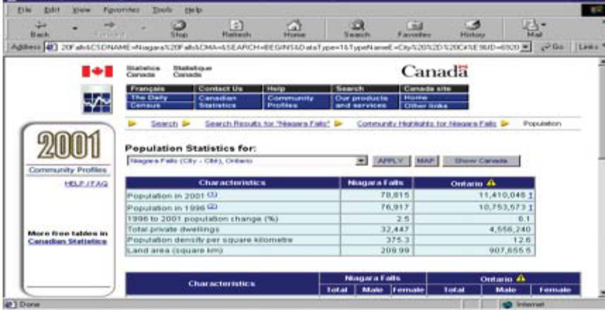
On the FMCiC website under Church Health. Lifeplan you can find the “pie chart” that you can download and use to compile the data.

- For the “Age Characteristics” category take the stats for each category and insert them on the “Age” pie chart.
- Scroll to the next one down for “Marital Status”. Take the total numbers for “Married (and not separated)”, “Living Common-law”, “Single”, “Separated”, “Divorced” and “Widowed” categories to put on the “Marital Status” pie chart.
- Scroll down to the “Family Characteristics”, take the total numbers for “Married-Couple”, “Common Law Couple” and “Lone Parent”, and place in “Family Characteristics” pie chart.
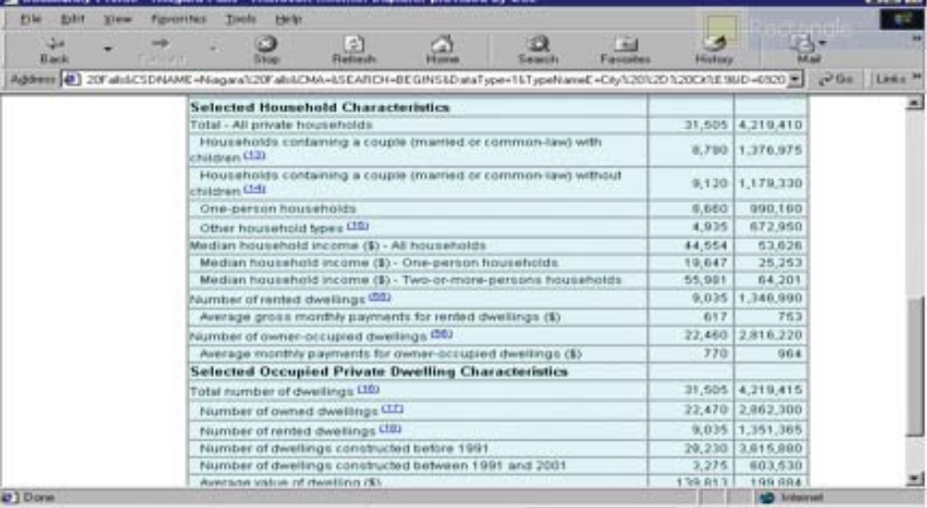
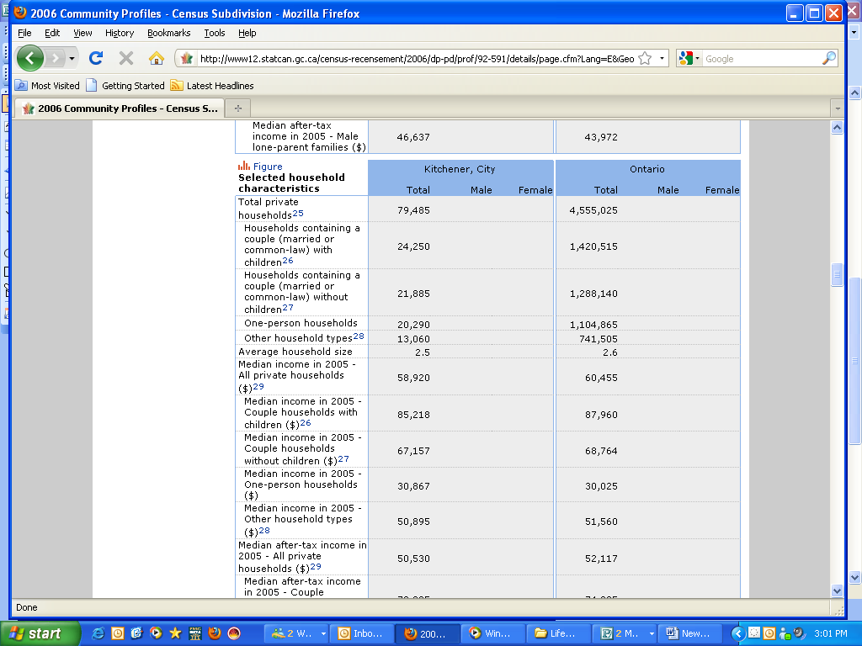
You can tabulate your results to create graphs to present to your congregation by downloading the “pie chart” from the website, http://fmcic.ca/lifeplan/

Additional Resources— NOTES ON “Gathering Stats/Data”

For the minimal cost, they give you a TON of data to sift through. They also have some great advice for how to identify contrasts or common areas between the community demographics and your congregational stats. HOWEVER, all of the information they give you has to be squashed & manipulated in order to get the simple picture that the Lifeplan instructions give you for free. For Lifeplan, save yourself time & money and follow the directions. I only did that after trying to make things work the hard way!

KNOW WHAT TIME IT IS?

Appendix 2 - Congregational Demographics

LOCAL CHURCH DEMOGRAPHICS

This information can be collected by a staff member who knows the demographics of the congregation. It is not necessary to ask each member of the congregation to provide this information. This information is general knowledge only, using approximations where applicable, and is not meant to be completely precise.

Date: __________________________
Name of church:________________________
Location Address:_______________________
Mailing Address:__________________________
Phone:______________________
Contact Person:__________________________
Mailing Address: _________________________
Phone: ______________________
Membership
Total Membership: ______________
Number of new members in the past five years ______________
Average Attendance:
Morning Worship ______________
Sunday Evening (if applicable) ______________
Discipleship Ministries
Christian Education Classes ______________
Small Groups (Mid-week programs) ______________
Family Characteristics: (from your Church
Directory/mailing list)
Number of families ______________
Married couple families ______________
Common-law couple families ______________
Lone-parent families ______________
Number of owned dwellings ______________
Number of rented dwellings ______________
Average value of dwellings ______________

Age Distribution of Members and Adherents:
Total Male Female
Age 0-4 _____ _____ ____
Age 5-9 _____ _____ ____
Age 10-14 _____ _____ ____
Age 15-19 _____ _____ ____
Age 20-24 _____ _____ ____
Age 25-29 _____ _____ ____
Age 30-34 _____ _____ ____
Age 35-39 _____ _____ ____
Age 40-44 _____ _____ ____
Age 45-49 _____ _____ ____
Age 50-54 _____ _____ ____
Age 55-59 _____ _____ ____
Age 60-64 _____ _____ ____
Age 65-69 _____ _____ ____
Age 70-74 _____ _____ ____
Age 75-79 _____ _____ ____
Age 80-84 _____ _____ ____
Age 85 + _____ _____ ____
Marital Status:
Total Male Female
Single ____ _____ ____
Married ____ _____ ____
Separated ____ _____ ____
Divorced ____ _____ ____
Widowed ____ _____ ____
Common-law ____ _____ ____

KNOW WHAT TIME IT IS?

Snapshot of where congregation is at in terms of giving:

1. Number of households in the congregation is: ___________
2. The average household income (estimate) is: ____________
3. Total estimated income of congregation is:
(#1 x #2) __________
4. Last year’s total giving: ___________
5. Average dollar giving per household was :
(#4 divided by #1) ___________
6. Average percentage giving per household of total income was: (# 4 divided by # 3) ___________

KNOW WHAT TIME IT IS?

Appendix 3— Community Leader’s Survey

We suggest that you sit down with the major “watchers” (ie—Police, ER Nurses, Community Health Officials, Food Bank Directors, Mayor, Reeve, MP, MPP, etc….) of your community to get their input on the following questions.

Community Leader’s Survey

1. What are some of the distinctives that give this community its identity?

2. What are some of the major issues facing the community at this time?

3. Can you identify the significant groups of poor, disadvantaged or marginalized people in this community?

4. What are some of the needs people may have in this community that churches are currently attempting to meet? What’s working & what’s not, in your own view?

5. Can you suggest major needs in the community with which churches are not involved, but could be if they were willing?

6. Are there any other people I should talk to so I can find out more about our community?

7. What advice would you give a new pastor in this community?

KNOW WHAT TIME IT IS?
Appendix 4 - Congregational Survey

Congregational Survey

We would like to invite you to express your opinions in this survey. The results of this survey will help us as a church discover what we like and value presently about our church and what we hope could become part of our future together as a congregation. Type in the link on the web to access the “Tally of the Congregational Survey”

What follows is an example of a type of survey you can do. Please feel free to adapt or change it to suit the needs of your congregation. If you would like to help put together your own survey or you would like to see other examples of survey other congregations have used, please contact the Director of Church Health at marc.mcalister@fmcic.ca

Recommendation: It’s best to plan for the whole congregation to take this survey together on a Sunday morning. It is also best to hand everybody a paper copy to fill in. You can always make arrangements for people who have missed that Sunday to do the survey the following week

Survey Link: http://fmcic.ca/lifeplan/
If you use this survey in the link a tally sheet is provided on the website
KNOW WHAT TIME IT IS?

Information
Gender:
Male / Female
Are you volunteering in this church?  Yes / No | Do you lead volunteers?  Yes / No
Are you a financial supporter?  Yes / No | Are you on the Board?  Yes / No

1. Circle up to six words or phrases that express what you value most about our church?
United | Flexible | Friendly | Good at Evangelism
Meets my needs | Conservative | Caring for the people in the church | Energetic
Visionary idea/plans | Generous with our talents | Prayer is a Priority | On Track
Contemporary | Caters to all generations | Church Planting Vision | Good Leadership
Well Organized | Spiritually Mature | Great Music | Task Focused
Growing (size) | Genuine | Cell/Small Groups | Open to New People
Focused on Neighbourhood | Family Friendly Activities | Sense of Tradition | Out of step with the world
Clear Plan | Fun | People Here Help Me Grow | Opportunities to Use My Gifts
Location/Building | Solid Bible Teaching | Spirit Led People/Ministries | Our concern for the Poor
Quality Worship & Prayer Life | Great Pastor | Good Children’s Programs | Friendships
Good Youth Group | Generous with our time | Holy | Laid Back Attitude
Clear Communication Between Leaders & Congregation | Generous with our money | Free Methodist Emphasis | People often meet Jesus here
Practical Sermons | Cares About Missions | Train me how to serve others | Everyone Feels Welcome
I can bring my non-Christian friends here | Lots of different people involved | Good Coffee | ___________________
KNOW WHAT TIME IT IS?

2. Rate the importance you give to the following values that Christians over centuries have placed on the
purpose of a local church.
"1" would indicate a low value in your opinion and a "6" would indicate an extremely important value.
Everyone needs to know Jesus and have an opportunity to use their spiritual gifts to reach out. | 1 2 3 4 5 6
The church is strongest when it connects locally, nationally, and globally to accomplish its mis-  sion. | 1 2 3 4 5 6
Churches and individuals within the church are supposed to grow and reach out to the un-  reached. | 1 2 3 4 5 6
The church is primarily a place for developing believers. | 1 2 3 4 5 6
Lay people in the church are team players alongside the pastor. | 1 2 3 4 5 6
Life long learning is essential for knowing God intimately and being faithful. | 1 2 3 4 5 6
We glorify God and show His love to others when generosity is modeled in the local church. | 1 2 3 4 5 6
The church should lead the way in modeling holiness and social justice for all. | 1 2 3 4 5 6

3. In your opinion what six words or phrases best express concerns you have about our church?
Only meets our needs | Discouraged | Looks after itself
Unrealistic | Ingrown | Contemporary
Conservative | Tired members and leaders | Caters to our Community
Caters only to the young | Out of Step with the world | Focused on itself
Selfish | Prayerless | Poorly led
Institutionalized | Spiritually superficial | Unclear communication
Music | Fractured | Directionless
Task Focused | Uncaring | Infighting
Too outward focused | Traditional | ______________________

4. In your opinion, to what sort of people IS this church most attractive? Circle three.
Families | Youth | Young Adults
Children | Ethnic Groups | Free Methodists
Lower Income | Singles | Blue Collar
White Collar | Single Parents | Seniors
People who are searching for God | _________________________ | ___________________________

5. What sort of people do you wish our church WAS more attractive to? Circle three.
Families | Youth | Young Adults
Children | Ethnic Groups | Free Methodists
Lower Income | Singles | Blue Collar
White Collar | Single Parents | Seniors
People who are searching for God | __________________________ | __________________________
KNOW WHAT TIME IT IS?

6. What sorts of things will we need to do as a church to become more attractive to these people?
Family friendly activities | More training to serve | A new location/building
New leadership | Solid Bible teaching | Opportunities to use my gifts
More concern for the poor | Quality worship and prayer life | More Fun
New pastor | Visionary ideas/plans | A clearer plan
Plant a church | More people involved | More generous with our talents
A better youth group | More focus on missions | Focus more on the neighbourhood
Be a place I can bring my non-Christian friends to | Clearer communication between leaders and congregation | A place where people meeting Jesus
More United | Free Methodist Emphasis | More evangelism
A laid back attitude | Spirit Led people/ministries | Practical sermons
Better coffee | More open to new people | More generous with our money
More Flexible | More Friendly | More Spiritually Mature
Cell/Small Groups | Meet my needs | More Conservative
More Caring for the people in the church | More generous with our time | Change in Music
Everyone Feels Welcome | More Energetic | Make Prayer a Priority
Better Children’s Programs | More Organized | Get back on track
More Contemporary | Cater more to all generations | More Focus on Growth (size)
More sense of tradition | Not so worldly | Stronger Friendships
Focus on Holiness | Focus on Helping People Grow | _______________________
KNOW WHAT TIME IT IS?

Please indicate your level of agreement or disagreement with the following statements by circling the number that most closely represents your opinion. "1" indicates strong disagreement and "6" indicates strong agreement.
The service should be orderly and traditional | 1 2 3 4 5 6
The service should be informal and contemporary | 1 2 3 4 5 6
The service should balance the needs of the members and the people we are trying to  reach. | 1 2 3 4 5 6
It is important that new people become a part of this church. | 1 2 3 4 5 6
We need to plant churches to reach our community. | 1 2 3 4 5 6
God wants to move us into some uncomfortable areas. | 1 2 3 4 5 6
The comfort of people new to Christianity is more important than my comfort. | 1 2 3 4 5 6
It is more important to help Christians grow than to reach out to people who don't know  Jesus. | 1 2 3 4 5 6
I think the pastor should be the one to set direction of the church. | 1 2 3 4 5 6
I think the congregation should set the direction of the church. | 1 2 3 4 5 6
The most important tasks of the church should be done by the pastor. | 1 2 3 4 5 6
I would like to see more women in leadership here. | 1 2 3 4 5 6
I think that we should take things as they come rather than planning and setting goals. | 1 2 3 4 5 6
Change is pretty easy for us as a congregation. | 1 2 3 4 5 6
It is more important that we move toward our goals than attempting not to hurt or offend  someone. | 1 2 3 4 5 6
We should regularly hear sermons on generosity of time, talent and money. | 1 2 3 4 5 6
It's important to ask for regular and sacrificial gifts in order to fulfill our mission. | 1 2 3 4 5 6
We need to regularly provide support and assistance to those who are in financial crisis  inside our congregation. | 1 2 3 4 5 6
We need to regularly provide support and assistance to those who are in financial crisis  outside our congregation. (i.e., immediate neighbourhood, in our town, etc.) | 1 2 3 4 5 6
I think it is important that we reach out to people of cultures different from our own. | 1 2 3 4 5 6
It's important for our church to be active in supporting cross-cultural mission work. | 1 2 3 4 5 6
Our church needs to be actively involved in issues of concern to our community. | 1 2 3 4 5 6

On behalf of the pastor and board we would like to thank you for taking the time to fill in this survey. This information will become an essential part of the decision making and direction of the church. If you have any questions about this survey or this process in general please contact the office.

KNOW WHAT TIME IT IS?

Appendix 5 - Natural Church Development (NCD) Instructions

NCD Process:
Please refer to the NCD website for information on what NCD is; how to conduct a survey; downloading forms for completing the NCD Church Survey; and much more information:
http://ncd-canada.com/

If you have any questions or concerns, please contact Davika at 905-848-2600 ext. 205; or email – davika.dotson@fmcic.ca or
NCD, Bill Bickle at fordelm@sympatico.ca

Note - If you would like some help going through your results once you have received them please contact Marc McAlister at marc.mcalister@fmcic.ca

Cost:
The price is $400 for first Survey and $375 for subsequent ones (the same as if you do them on your own). This fee includes a one hour debrief of the results with the pastor and/or leadership team with NCD Canada over the phone

The Building Blocks of Natural Church Development
Our introduction to Natural Church Development is structured around five questions which form the “Building Blocks of Natural Church Development”.

Building Block One - What should we do?
The question remains, if God does his part in giving the “all-by-itself” growth, what is our part? Our first question is “What should we do?” Our part is removing the environmental resistance by ensuring health in the eight essential areas, Empowering Leadership, Gift-oriented Ministry, Passionate Spirituality, Functional Structures, Inspiring Worship Services, Holistic Small Groups, Need oriented Evangelism and Loving Relationships. This task is facilitated through regular church quality evaluations. Schwarz has developed a tool for exactly that purpose. The church evaluation (or profile) will test your church for quality in each of the essential areas. The evaluation is done by 30 participants, carefully selected according to strict criteria, who complete 91 questions about their experience of church life. Their answers are processed with highly sophisticated software that compiles and weighs each response and calculates a health score for each essential quality characteristic. The process has been designed to be extremely accurate by acceptable scientific standards. For those who have studied statistics, the scales of the church profile have a reliability factor between r = 0.75 and r = 0.89 depending on the specific scale.

Building Block Two - Where do we start?
Our next question and building block of NCD is “Where do we start?” The strategy is simple. Imagine a wooden barrel with staves banded together.

The staves are varied in height. How much water will the barrel hold? You will be able to fill the barrel only to the level of the lowest stave then the water will begin to pour out. If you want the barrel to hold more water, you need to raise the height of the lowest stave.

1. What should we do?
2. Where do we start?
3. How should we do it?
4. Why should we do it?
5. What steps should we take?

KNOW WHAT TIME IT IS?
This illustration is applicable to church life. If we equate the staves with the each of the eight quality characteristics and the water level is your service attendance, your church will grow only to the point where your weakest quality characteristic begins to hinder church growth. If the church wants to continue to grow it, will have to raise the quality of its minimum factor. Develop a strategy to grow healthier in that area and you will begin removing the environmental factors inhibiting your growth.
Building Block Three - How do we develop the eight quality characteristics?
Our next question and building block of NCD is “How do we develop the quality characteristics?” If the eight quality characteristics are what you need to develop, then the “Natural Growth Principles” (or biotic principles) are how you need to develop those qualities. There are six natural principles as follows;
- Interdependence - all parts of the church are
aware of the impact of what they do on other
parts and ensure that the impact is positive.
- Multiplication - every part of the church is
looking to reproduce itself.
- Energy Transformation - all the energy in the
church is harnessed and directed towards
achieving its God-given goals.
- Multi-usage - the church invests its resources in such a way that its various parts become self-sustaining, freeing up resources to be used elsewhere.
- Symbiosis - diverse parts of the church are encouraged to work together in synergistic “win-win” relationships.
- Functionality - all areas of the church are regularly assessed to ensure they are contributing to the overall healthy growth of the church as an organism. When you apply these principles to grow healthier in each of the quality characteristics, an amazing thing happens; the natural growth potential is released according to God’s design for all organisms in the universe. This may sound mystical but think about it for a moment, what would happen if all your ministry leaders applied just one of these principles, “Multiplication”. Imagine every one of your ministry leaders training and equipping someone to do their ministry who would also be training and equipping another. Imagine every ministry duplicating itself. Imagine every church planting another church. The ramifications for church growth are staggering. If you add the other five principles into every ministry leader’s thinking and actions, you will be a growing church. Decisions that integrate natural growth principles will help your church to make the very best use of precious church resources. These principles are effective in many organizational settings.
Building Block Four - Why do we develop the eight quality characteristics?
We have already learned that we partner with God. We tend to the environment and God does give the growth.
1. NCD rejects merely pragmatic and a-theological approaches (“the end justifies the means”) and replaces them with a principle-oriented point of departure.
2. NCD has no quantitative approach (“How to get more people to attend services?), but looks at the quality of church life as the key to church development.
3. NCD does not attempt to “make” church growth, but to release the growth automatisms, with which God Himself builds the church.
The Discovery: What happens when we attempt to make the church grow? A lot of hard work that often seems like we are pushing a square wheeled cart. When we attend to the environmental factors and allow the “God designed” growth automatisms to grow the church, church begins to look and feel a lot different. Our sail is set and the wind of God’s spirit moves us forward. Those nasty square wheels have been replaced and the church begins to grow “all-by-itself”.

KNOW WHAT TIME IT IS?

Building Block Five - What steps do we take to develop the eight quality characteristics?

The NCD Cycle (Prevailing Church Cycle) is a strategic process that provides a framework for action and affords church leaders the most out of their annual NCD evaluations. It could be thought of as the Functional Structures” of NCD. The cycle involves moving through a process of six phases.
Phase 1: Prepare for the Evaluation
You begin by preparing for the evaluation by gaining understanding, sharing concepts, securing a level of commitment to the process etc.
Phase 2: Conduct the Evaluation
The next phase is to actually conduct the survey. This must be done according to very strict scientific standards.
Phase 3: Analyze the Evaluation
This is a process of careful consultation with a number of groups in the church. The goal is to uncover specific growth barriers.

Phase 4: Develop an Action Plan
Once you have a good understanding of what your growth barriers are within your minimum factor you develop a plan to eliminate those “environmental inhibitors”.
Phase 5: Implement Your Action Plan
You implement the action plan and monitor momentum.
Phase 6: Re-cycle
We recommend that you re-survey after about 12 to 18 months. The next evaluation will give you an indication of your progress to greater health and re-establish a new minimum factor to address.

The cycle has been developed after years of experience of watching churches move through the process. The essence of the NCD Cycle is “Evaluation… Action Planning… Reevaluation.”

Visit the website tools and walk through the
step-by-step instructions for each phase.
www.ncdcanada.com



Additional Resource - NOTES on “Doing an NCD Survey”

I highly recommend getting people together for a meal.

There is ALWAYS resistance to doing this, and it ALWAYS feels like pulling teeth to get 30 people there, but it’s SO worth it. We did ours on a Sunday after church. The church paid for the meal, and people were able to enjoy eating & chatting together. Before we took the survey, I walked the people through an edited version of the “Overview of NCD” powerpoint found here:
http://www.ncdcanada.com
The feedback I received was that I was trying to get through the material so fast, that I forgot to make it interesting & fun to learn about the in’s & out’s of the NCD story. It is fascinating stuff, so relax & enjoy telling people about it!
The new version of the survey is way easier to understand and fill out than previous editions. I’ve heard so many complaints about how hard it was to understand the questions...this one is SO, SO simple! I highly recommend the Profile Plus - all the basic version does is raise more questions about WHY the scores are the way they are. Profile Plus gives you so much more to work with.
NCD is a great partner with the Ministry Map Analysis. I recommend you to do the Ministry Map before NCD - it raises some GREAT questions that NCD answers!

KNOW WHAT TIME IT IS?

Appendix 6 - Ministry Map Instructions

The Ministry Map
A helpful exercise in developing a new direction for your church community. A ministry map is designed to show an overview of where most of your church’s energy is going. Once completed, this overview can help you find areas of under focus and over focus. By finding these areas you and your church can much better manage a more healthy profile.

Where it comes from:
The Ministry Map looks at four key movements of church life as we participate in God’s work in our world. This idea is based on Ephesians 2:1-15.

1 As for you, you were dead in your transgressions and sins, 2 in which you used to live when you followed the ways of this world and of the ruler of the kingdom of the air, the spirit who is now at work in those who are disobedient. 3 All of us also lived among them at one time, gratifying the cravings of our sinful nature [a] and following its desires and thoughts. Like the rest, we were by nature objects of wrath. 4 But because of his great love for us, God, who is rich in mercy, 5 made us alive with Christ even when we were dead in transgressions—it is by grace you have been saved. 6 And God raised us up with Christ and seated us with him in the heavenly realms in Christ Jesus, 7 in order that in the coming ages he might show the incomparable riches of his grace, expressed in his kindness to us in Christ Jesus. 8 For it is by grace you have been saved, through faith—and this not from yourselves, it is the gift of God— 9 not by works, so that no one can boast. 10 For we are God's workmanship, created in Christ Jesus to do good works, which God prepared in advance for us to do.
God, in all of His love, mercy and skill with human lives, can take dead people and make us alive, adopts us as children, trains us to be royalty, and then employ us in the family. What is the family business? It’s to take dead things and make them alive, adopt them as children, raise them to be royalty and then employ them in the family business. What is that family business?
Is to take dead things….
These are the basic functions that God performs in, through, and among us. It would stand to reason that we need examine the things that we do in our churches, both formally and informally, against this process. That is what the Ministry Map attempts to do.

The Basics:
The process of life described in Ephesians 2 resembles this diagram. In four parts, they are:
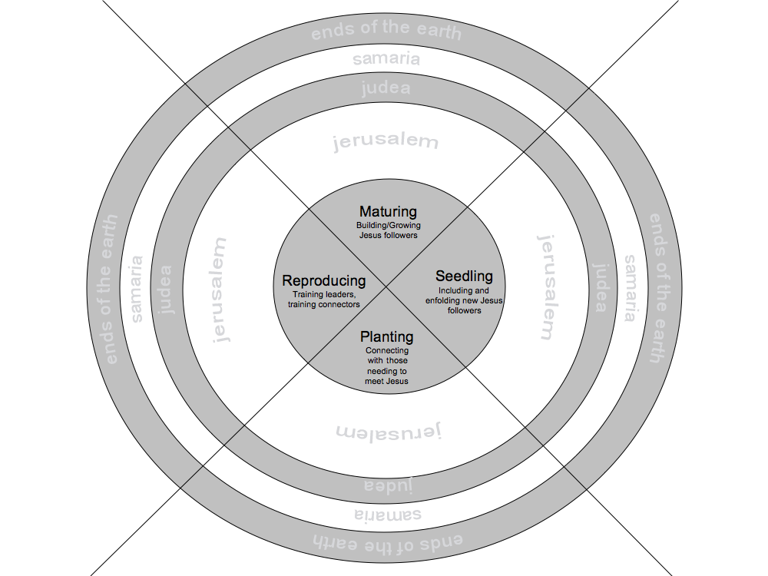

1. Planting: The beginning of life (taking dead things and making them alive) Ephesians 2:5—”made us alive in Christ”
The soil must be prepared. Seeds sown. Water. Wait. Hope. Not work for the impatient or results driven because all of the action is underground and hard to see.

In the kingdom this is all of the work we do in our community. This is all of the no strings attached loving work that we do… you know the cup of cold water stuff (without a tract at the bottom of the glass). This work is all about an extravagant invitation; an invitation to find a place at the family table. The motto is “If you come you belong.”

This is the equivalent to MilePost #1 on the Journey toward wholeness in Jesus

KNOW WHAT TIME IT IS?

2. Seedling: Protecting and nurturing new life (adopting them as children).
Ephesians 2:5-6—God raised us
Seeds germinate and peak out above the soil. This is not the time to look for fruit or get crazy pulling weeds.
In the kingdom this is the phase Jesus described in the Parable of the Sower (Luke 8:4-8). Lots of
seed. Lots of germination. Not everything lives.
You are the cheer leader (not the screaming
coach) for the new life that God is bringing out of your neighbourhood.

This is the equivalent to MilePost #2 on the Journey toward wholeness in Jesus

3. Maturing: New life now dominates the soil (raising them to be royalty).
Ephesians 2:6-“seated us with him in the heavenly realms”
You officially have a garden (provided there are
more veggies than weeds). Now is the time to do
some coaxing of your little plant. You need a hockey stick driven in the soil beside it. Bind your little plant to that. That way it’ll grow up nice and straight. That way the fruit won’t rot on the ground when it comes. Pull some weeds. Soon you’ll see the flowers that precede the fruit.
In the kingdom of God this is what John Wesley referred to as the “works of piety”. If you want this little plant to grow up straight. If you don’t want their works to rot on the ground. They are going to need to bind themselves to disciplines of the faith. Accountability. Develop a prayer life. Fertilize with scripture. Feed with communion. Good teaching. Soon you start to see the familiar life of Jesus emerge.
This is the equivalent to MilePost #3 on the Journey toward wholeness in Jesus

4. Reproducing: New life produces fruit that contains the next generation of new life.
Ephesians 2:10 “created in Christ Jesus to do good works, which God prepared in advance for us to do”

Your garden is starting to look pretty good. You’ve got all kinds of produce. Time to make some decisions. How much goes into the next tomato sandwich. How much gets dried out and used next year as seeds.
In the kingdom of God this is what John Wesley called “works of mercy.” This is not merely giving back to the community. This is the final spiritual discipline. We begin to see the face of Christ in the people we serve. At first it may only be in the faces of the people in our church. But the true sheep of God (Matthew 23) find Jesus face among the poor, the imprisoned, the lonely, and the sick. The pinnacle of Jesus’ life on earth was in making a sacrifice of himself. We are called to the same. It is only in this place that we are truly mature. It is only in this place that we set the stage for generations to come.

This is the equivalent to MilePost #4 on the Journey toward wholeness in Jesus. If you are not familiar with Journey toward wholeness in Jesus see page 35

Instructions:
Begin by printing off the exercise sheet on page 35.

1. Dust off your mission statement. Does it look a lot like most church mission statements? Good. That means that it says something along the lines of what’s in Ephesians 2. Now look at the verbs in that mission statement. Rename the 4 zones of this chart using the words of your mission statement. It’s better for you to use your own internal labels and language when you think about what is going on in your church.

a. For Example: The mission statement “To enfold, nurture and care for people, discipling them into fully devoted followers of Christ.” Would fit the inner circle like this: Enfold= Planting, Nurture and Care=Seedling, Discipling=Maturity, Fully Devoted =Reproduction.

2. Sit down with your whole congregation, your ministry team, or just your board. Whatever you think you can handle. Together, make a list of all the ministries/activities that your church regularly engages in. Place each of the ministries and activities in the appropriate zone/ring on the map by asking the following questions: What MOST often happens in this activity? Who MOST often comes? What do we MOST often talk about?

KNOW WHAT TIME IT IS?

Definition of the zones and rings:

The inner ring (without words) is for ministry in your church community. In and Acts 1:8 sense, this is your Jerusalem.
The next ring is for ministry in your local community or neighbourhood. In and Acts 1:8 sense, this is your Judea.
The next ring is for ministry to people in your town, region, province or country but outside your own culture group. In and Acts 1:8 sense, this is your Samaria.
The next ring is for ministry to people outside your country. In and Acts 1:8 sense, this is your Ends of the Earth.

Some notes:
1. Be honest. There will be a tendency to fudge the location once an unbalanced picture emerges.

a. Do you have an Alpha group? Most times that belongs in the Seedling zone. But are most of the people in your Alpha group already long term Christians? If that’s the case it probably belongs somewhere else.
b. Sunday Morning. Where does it fit? Ask yourself, who are the majority of people that come? Where are they at spiritually? As much as possible fight the temptation to think about who should be there and think about who is there.

2. To interpret the results ask yourself these questions:
· Does our map look healthy and balanced? Are there areas that we spend little or no time or energy on? Are there areas that we spend too much time and energy on?

· Is what we are doing meshing with how we now understand our context and ourselves from the data we collected?
· What new skills or attitudes might we need to develop, given what we're learning?
· What other groups might already be working on ideas or actions that help us think through what we need to be doing?
· Why do we keep functioning in certain ways that we know are counterproductive to accomplishing what God has put in front of us to do?
· Which elements of our tradition are of great service to us, and which do we need to rethink?
· What new information do we need in order to make good decisions about some of our current activities?
· Are current budgeting processes helping or hindering our new understanding?
· What new skills do we need to develop to be effective in this context?
· Are the expectations we have of our leaders empowering them to form us into what we need to be?
· Which areas should we focus on, and which should we set aside because of our priorities?

Place a square around activities and ministries that you think need to change in some way. Using another colour pen depict the new location of where you think it needs to be.

4. Take a digital photo of this piece of paper or scan it. Send a copy to the Ministry Centre. Send a copy to your network leader. Send a copy to everyone on your Ministry Team, your Board, and anyone else that you think might be interested.

KNOW WHAT TIME IT IS?

The Ministry Map

Ministries in the Church:

1. _____________  2. _____________  3. _____________  4. _____________  5. _____________  6. _____________  7. _____________  8. _____________  9. _____________  10. _____________  11. _____________  12. _____________  13. _____________  14. _____________  15. _____________ | 16. _____________  17. _____________  18. _____________  19. _____________  20. _____________  21. _____________  22. _____________  23. _____________  24. _____________  25. _____________  26. _____________  27. _____________  28. _____________  _____________  _____________ | 31. _____________  32. _____________  33. _____________  34. _____________  35. _____________  36. _____________  37. _____________  38. _____________  39. _____________  40. _____________  41. _____________  42. _____________  43. _____________  44. _____________  45. _____________ | 46. _____________  47. _____________  48. _____________  49. _____________  50. _____________  51. _____________  52. _____________  53. _____________  54. _____________  55. _____________  56. _____________  57. _____________  58. _____________  59. _____________  60. _____________
KNOW WHAT TIME IT IS?
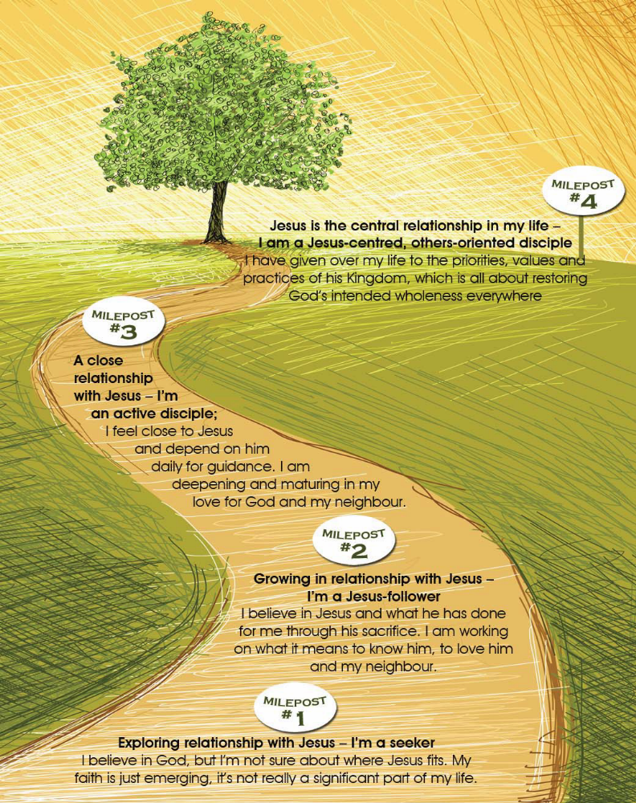

Journey toward wholeness in Jesus
http://fmcic.ca/the-journey-toward-wholeness-in-jesus-introduction/
KNOW WHAT TIME IT IS?

Additional Map Resources— Sample - Ministry

We did the Ministry Map in the “Data Gathering” phase of LifePlan. Personally, I think that’s the time to do it, and I suggest doing it before you get the NCD results back.
(see my previous entry).

Don’t go into this exercise expecting too much from it. The main purpose is to get a general overview of where you spend your time & energy - no more. I got discouraged after leading our board through it because there were no huge revelations, and people didn’t seem to be having very much fun. I felt like I had not been a very good facilitator, or prepared people properly for the exercise. Some people fought me when I tried to nail down ONLY ONE category for each ministry activity. Others disagreed with the 4 categories (I did too - I wanted to use the Purpose-Driven ministry categories instead).

When I debriefed with my coach the next day, he talked me down off the roof. I was reminded that the goal of the exercise is to generate one or two really good questions; To get a realistic picture of where our time & energy are being spent.
KNOW WHAT TIME IT IS?

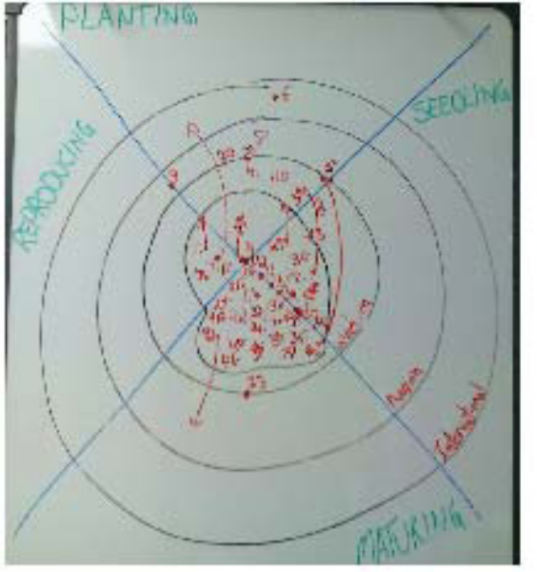

Here’s what we got out of it:

1) Our Mission Statement is not complete enough to
encompass all of the biblical purposes God has for His
church. I got permission from the board to revisit the Mission Statement as a part of the LifePlan process - HUGE.

2) The question that came up was, “How can we spend
SO much time & energy trying to mature the people in
our church & end up with such immature Christians?”
Something that we will be able to wrestle with in the coming months. The NCD will point out if we ARE good at maturing Christians or not. I think we’ll also be challenged to rethink what we mean by “mature Christian”.

3) We noticed that we don’t spend a lot of time or energy in training & equipping our people to reproduce. Could THIS be why our people are not showing evidence of maturity? Another good question.
KNOW WHAT TIME IT IS?

Where does our congregation live?

These are instructions for mapping where your congregation lives

To set up your map…

- You need a gmail account to sign in
- Go to Google.com
- Choose Maps
- Click on My Places
- Sign in with your gmail account
- Click on Create Map
- Give it a Title and a description
- In the privacy settings, choose ‘Unlisted’
- Click ‘Save’ and ‘Done’ (located above
the title)

To add Addresses to the maps…

- Type in an address in the search bar and
click the search button
- On the left side panel, you will see an
address
- Click on “Save to Map” (the 3rd option
from the left)
- You will get a drop down with all the
names of the maps. Choose the map you
created and click on SAVE (only once)
- Type in the next address and repeat the
steps above

To remove any Addresses… (e.g. If you press SAVE more than once and an address is duplicated in the list)

- Click on “My Places” and choose the
Map

- Click on Edit
- Locate the address on the Left side panel
and click on it.
- A small window will open on the right
side…
- At the bottom (left side), is the delete
option. If “delete” does not appear, click
EDIT again
- Click on it and the entry is removed from
the Map
- Click – Done

To save the Mapping work in a file once the data entry is done …

- “Hide” the panel on the left by clicking
the arrow at the top right of the panel.
(When this is done, only the map will be
on the screen.)
- Adjust the map (zoom in/out ) to get a
good layout
- Open a new word document.
- Go to the Map page.
- Press Shift + Print Screen (located in the
top row of your keyboard)
- Go to the word document
- Press Ctrl + v (This pastes the map in the
Word document.)
- Click on picture of the map.
- Adjust the size of the map, by clicking on
a black square and pulling the picture out
to a larger size.
- Save the file.

KNOW WHAT TIME IT IS?

Sample Directory
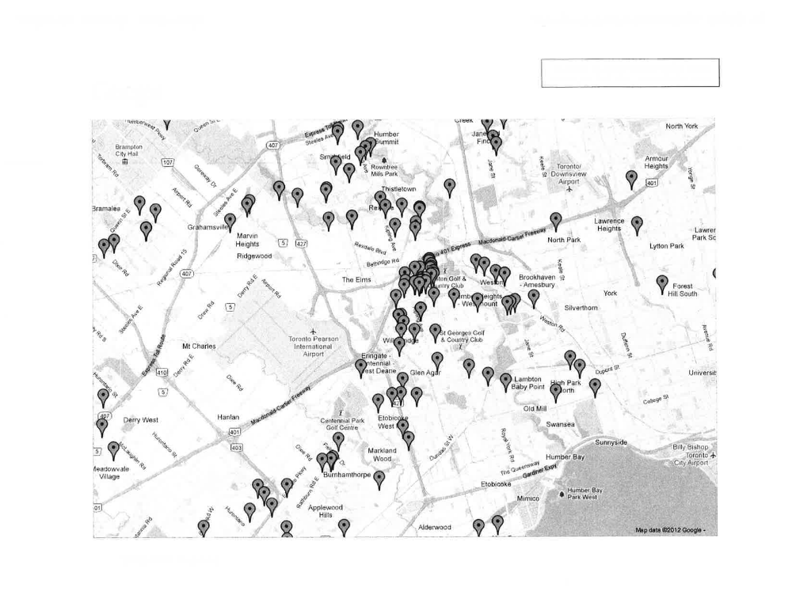

Google Map

FIND GOD’S OPPORTUNITIES

Appendix 7 - Instructions For the Writing Team

The goal here is to condense all of the information you have collected and tell your congregation a story about itself and where it lives. To write a report to the congregation use the raw data and the following process.

1. Identify What’s Most Important:
List extremes in the data: biggest, best, worst, least
What repetitions or themes do you find?
What jumps out at you in this information?
What is most urgent?
What is most crucial?
What is most possible?
What is most credible?
Write out what’s “Most Important” in short phrases.

2. Implications.
Now draw out the IMPLICATIONS . THIS IS THE HARD PART, BUT THE BEST PART.

Your implications could begin with phrases like:
“Unless we start…., if we don’t address…., unless we stop doing…and start…….we will not see Kingdom growth.”

Now go back to the data to support your claim. Find the symptoms of the implications in the information you have collected. List those symptoms under each Implication.

For instance:

Implication 1: Unless we increase the amount of Ministry participation and leadership development we will not see Kingdom growth.
Symptom - People are not very generous with their time (Congregational Survey)
Symptom - Small Group and Ministry Team Leaders identify that we are short of volunteers for ministry work and bulleting appeals for help do not seem to work. (Observation and statements made)
Symptom - Small Group Leaders are not well trained for their tasks. (NCD)
Symptom - We do not regularly praise and recognize our volunteers. (NCD)

3. Prayer Questions:
Write out Prayer Questions that you would like your people to ask God about. Avoid the use of “yes or no” and “leading” questions. Instead invite your congregation to imagine what a God-shaped outcome would look like if He were to help your church solve this problem, or rise to this challenge, etc…

For instance:
Questions to ask God about

What would it look like if God helped us with this?
What would it look like if more and more people found their place and calling in our church family?
What would we need to change, stay the same, or start doing if we want to increase the number of people that participate in meaningful work and ministry here?

During a worship service present this sheet to the congregation, along with copies of the raw data. Using the guidelines provided, the congregation will be called to a period of prayer, fasting, conversation and feedback on the paragraphs to the Writing Team.

FIND GOD’S OPPORTUNITIES
Additional Resources—Sample—Writing Team Report

FAITH FREE METHODIST CHURCH
Team Members: B. Graham, M. W. Smith, A. Grant, K. Troccoli, P. Clairmont, & K. Green

Presented to Board on May 11^{th,} 2010
Presented to Congregation on May 16^{th,} 2010
It is our desire as followers of Jesus Christ to live the life that He calls us to as individuals and as a church family. God has placed each one of us here at this church in this community for a reason. The purpose of this time is for each of us to know the role Jesus calls us to.
In June of 2009, the leadership (Official Board and Pastoral Staff) got together and decided to enter into a new process of strategic thinking called the LifePlan.

WHAT IS LIFEPLAN?
LifePlan is a tool designed by the Free Methodist Church in Canada as a way to help congregations move forward by asking not just the leaders but the entire church family to take time to hear what God is calling them to do. It encourages us to pay attention to our community, our church family, and the path the Lord wants us to take to serve Him.
Where We Are in the Process:
The leadership did research into all those factors that make up our church right now to get a current and detailed picture of what is happening at Faith Free Methodist Church and in the community around us.
Natural Church Development (NCD) – This is a diagnostic tool designed to show the health of a congregation. NCD looks at 8 biblical characteristics that make up a healthy church: Empowering Leadership, Effective Structures, Passionate Spirituality, Gift Oriented Ministry, Need Oriented Evangelism, Inspiring Worship, and Holistic Small Groups. This tool is used around the world by all denominations. A group of 30 people representing a cross-section of our church filled out the survey in January 2010.
Community Leaders Survey – Pastor J. Aniston interviewed prominent leaders within the community (Mayor & County Warden P. Brosnan, Police Chief B. Pitt, and Food Bank Director J. Roberts) to see how Faith can better serve the citizens of Haven and area.
Statistics Canada 2006 Census – Using the information gathered from the 2006 Census, we got a picture of the people in the community of Haven.
Local Church Demographics – A list of all current members and adherents was compiled by age group. Also, the average Sunday attendance for all Haven churches was obtained and charted.
Ministry Map – The Ministry Map was completed at the June 2009 Society Meeting, facilitated by Kim Henderson, Director of Personnel at the Free Methodist Church in Canada. All who attended the Society Meeting participated in performing this “ministry audit” to see where we as a church are currently putting our energies and resources.
Congregational Survey – The entire congregation participated by completing the Congregational Survey last month. The results of this survey have been posted around the church for all to reflect on where we are now and where we want to be in the future.

WHERE WE ARE GOING:
Prayer & Fasting
As a church body, we want to set aside time to make space for God to speak to each of us about how He would want us to go forward as a church. Jesus’ life gives us a model to use – whenever he needed to make big decisions, he would fast and pray. We are going to fast and pray for 28 days. Each Sunday evening (starting May 16th) will be a special time of corporate prayer to seek God. On June 12th here at the church we are also going to be holding a retreat day – where you can come and pray together and also pray alone.


Dream Session
On June 13th, we are going to come together for one church family worship service, following which we will celebrate with a meal together. Then we will hear how God has spoken to each of us as individuals from our times of prayer and fasting. We are going to be listening for the shared dreams and visions that God has brought to us and decide together which of these themes we will give our energies and focus to as a community of believers. We will finish our time with Communion.
Develop the Plan
From the Dream Session time, the Official Board and pastoral staff will come up with a Ministry Plan based on the picture painted for us as a church. The Plan will be presented to the church during our November Annual Society Meeting.
OUR FINDINGS:
From our research, these are the trends we are finding.
We as a church family saw a rapid increase in our Sunday morning attendance from 2006 to 2007. During the past two years, our attendance had plateaued. Over the past few months, we are experiencing a rise in attendance.

- THERE NEEDS TO BE MORE INDIVIDUALS WILLING TO BE PERSONALLY INVOLVED IN MINISTRY, OR OUR PASTORS AND CURRENT LEADERS WILL BURN OUT.

Congregational Survey: Tired Members & Leaders ranked as the highest concern about our church.
The highest scores of “things we want to do to be attractive to these people” places more responsibility on the pastor and leadership team.
The lowest scores reflect unwillingness to make personal sacrifice and commitment to church growth.

Questions to ask God:
What does God want me to do to take some of the load off our current leaders and pastors?
What would it look like if we all shared equally in the work God has for Faith FMC?
What sorts of things could God do through us if more people committed time, energy and money to our programs?
How will God help me step out of my comfort zone and get involved?

2. THERE IS A NEED FOR TRAINING AND MENTORING OF NEW LEADERS IN ORDER TO MAINTAIN EFFECTIVE MINISTRIES.
NCD Survey:
“The volunteers of our church are trained
for their ministries” had a below average score.
Current ministry leaders have “learned on the job,” but would benefit with training. No training has been made available for ministry.
Questions to ask God:
If there was more training/mentoring available, would we see more people stepping into leadership roles?
How could training and mentorship lead to more evangelism?
Is God asking me to be a leader of some ministry?
Is God asking me to step aside and train up a new leader?

FIND GOD’S OPPORTUNITIES

3. OUR CURRENT BOARD STRUCTURE HAS TWO PARTS: GOVERNANCE BOARD AND MINISTRY TEAMS. THERE HAS BEEN A LACK OF MINISTRY TEAM COLLABORATION.
NCD Survey:
Effective Structures scored low in “not meeting regularly for planning.”
There has been poor communication amongst the leaders.
Questions to ask God:
What will God direct us to do if we collaborate as a team?
How many more people can we reach if our ministries communicate strengths and needs?
How can God work through us as a unified body to help each other?
4. THERE NEEDS TO BE A SHIFT IN FOCUS WITHIN EXISTING PROGRAMS TO DISCIPLESHIP & RELATIONSHIP BUILDING.
NCD Survey:
Low scores in “Loving Relationships Current Profile”;
Poor representation in Small Groups;
“New Christians find friends in our church quickly” – very low score.
Keenagers works excellently – demonstrate loving relationships in their ministry.
Questions to ask God:
What is discipleship?
(Matt. 28:19, John 8:31, John 13:35, John 15:8)

What does discipleship look like in today’s society?
How does God want me to love?

5. WE NEED TO BE MORE OPEN TO CHANGE.
NCD Survey:
“Change is hard for us” had a high response.
This LifePlan process needs to be a part of our normal church life.
We need to keep moving forward.
Questions to ask God:
What does change look like for our church?
In what areas do we need to change?
How is my personal “comfort zone” hindering God’s plan moving forward?
6. a) ACCORDING TO PERTH STATS, THERE ARE A LARGE NUMBER OF 25-44 YEAR OLDS. ARE WE REACHING THEM?
Local Church Demographics:
NO! The greatest age concentration is 55+.
Questions to ask God:
What does God want us to do to reach these unchurched people?
What does God want us to be involved with in our community to reach this age group?

b) WE HAVE HAD PAST SUCCESS IN ATTRACTING YOUNG FAMILIES FOR A TIME, BUT WERE UNABLE TO RETAIN THEM.
Questions to ask God:
How do we make the young families in this community more of a priority?
What “family friendly activities” could we do?



Who is my neighbour?

Appendix 8 - Guidelines for Soliciting Feedback for the Writing Team

Bottom line: The conversations which follow this activity will be based on our mutual understanding of this report.

To facilitate mutual understanding, your feedback is important to us as the Writing Team. You may speak to a member of the team (insert team members’ names here), using the format below, to make your comments or ask your questions, or submit the following in written form. Whichever venue you use, we appreciate your help.
Having read the report and the data which supports this report, I think the Team did a good job clarifying this/these point(s) for this/these reasons:

1.
reasons:

2.
reasons:

3.
reasons:

There needs to be further clarification on this/these point(s) for this/these reasons:

1.
reasons:

2.
reasons:

3.
reasons:

I think the Team missed some thing(s) for this/these reason(s):
1.
reasons:

2.
reasons:

3.
reasons:

If there is adequate support for this report, the process will move forward. If there is less than adequate support for this report, as a congregation we will publicly review and make revisions as necessary.

TRUST EACH OTHER
Appendix 9 - Instructions for Dreamsession Facilitator

Bottom line: we want to hear from the congregation about what they heard God tell them during their time of prayer and fasting. To do this we need to facilitate a method to hear all voices.

The plan is simple:
1) we list all the ideas and dreams on chart paper, 2) we eliminate the duplicate ideas, 3) we get people set what they consider to be the top 5 priorities.

Before we get into the nitty gritty let’s talk about some questions we get asked from time to time:
“Won’t all the loud opinions dominate the conversation?”
No one voice can dominate this conversation. Because we divide the group into tables we eliminate the platform that loud opinionated voices need. Not only that but we give everyone the power to name the most important ideas. In our experience only the best supported ideas come to the forefront; hobby horses and broken records don’t get much traction in this kind of process.
“What if our church isn’t creative?”
We haven’t come across one of these kinds of churches yet… Something very creative takes place when a congregation takes time to ask the most creative person in the universe what to do next. So even if your congregation isn’t creative God certainly is.

1. LIST ALL IDEAS PRESENTED BY CONGREGATION:
Materials Needed: pens and papers for each table, chart paper, markers, 5 post-it notes for each person present.

Brainstorm:
Divide the congregation into small groups at tables. Each group has one pen and a stack of paper. One person records each idea for the group on paper. One person will verbally report for each group.

Rules for brainstorming:
- Do not debate, or let them debate each other
- List all ideas presented
- Ask that ideas be stated in the positive not the
negative
- Everyone’s ideas are accepted here
- Do not discuss the ideas
- Get at least 20 ideas

- Good brainstorming doesn’t have take a long time. Limit the time.

Reports to the Group:
- First group reports ideas to the whole congregation
- Ideas are recorded on a master chart in random order
- Next group reports ideas that are different from the first group
- Continue until all groups have reported
Prioritization:
- Each person has 5 post-it notes and numbers them 1-5
- Inform the congregation that when choosing prioritized ideas, each person must be committed to fully support their Number 1 choice with their time, talents and resources by asking themselves, “What does God what me to do?”
- Each person puts their post-it notes on the top five ideas which are their own priorities. Number 1 is placed on the idea which is the highest priority for that person, number 2 is the second highest priority, etc.
- Limit people to one vote per idea.

2. COLLATE THE RESULTS BY REVERSE WEIGHT:
(or fill in the Spreadsheet available at the Ministry Centre and it will do the work for you)
1 = 5 POINTS
2 = 4 POINTS
3 = 3 POINTS
4 = 2 POINTS
5 = 1 POINT
Develop a total weighted score for each item by multiplying the number of responses which are scored the same by their value and adding them together:

For example:
Values on Survey (High) 1 2 3 4 5 (Low)
Responses from Survey 2 6 3 5 2
Multiply (2x5) + (6x4) + (3x3) + (5x2) + (2x1)
Add 10 + 24 + 9 + 10 + 2 Total Score = 55
The 5 highest weighted scores will indicate the top five priorities of the congregation.

SAMPLE – DEVELOPING A MINISTRY PLAN

Here are some suggestions others have made on how to do this:
- Take each priority and examine how each affects staff roles and ministry teams.
  - Once you have a general sense of how to incorporate some of these new ideas it is a good idea to put your plan on a calendar.
  - Give each board member an area that they are to focus on this will act as their “portfolio”.

Below are the ideas that we are actively working on, or planning to develop over the next 5 years. They have been referred to individual Ministry TEAMS for development, calenderizing & for any other additions they want to make. The board’s job will be to reflect on all of this action & information & develop a big picture overview of our Mission, vision, values & priorities based on what we have learned. Theoretically, this will nicely fit “on top” of the strategic plan that is beginning to come together.

Category | Ideas
Overall | Simplify Church Programming & schedule to enable a greater balance towards relational evangelism. “Simple Church” – help each person develop a balance of one ministry commitment, one growth opportunity, and a community involvement commitment (3-5 yrs)  Re-branding & intentional advertising – use newspaper ads, community bulletin boards, yellowpages  Adapt facility to meet ministry needs  Finance ministry to explore direct debit
Worship | Develop teams to create alternative worship spaces: hymns, coffee house, youth band, lent focus, testimonies  Easter – “all church” worship service at Comp
Maturity | 24/7 prayer room  “Bible University” to address the desire for deeper understanding of Scripture  Partner with youth ministry to develop young adults small group  1/month prayer times with various themes, and opportunities for testimonies. Single Parents group (1 or 3 for…) “single again”, “spiritually single” “unwed mothers”  Mom-to-mom support group – Serena Copley is ready to go!
Ministry Development | Promotional materials created by each ministry TEAM to be placed on the Info booth, as well as promotional videos for each ministry area.  Mentoring program – possibly by training seniors to mentor younger folks?  Annual Ministry Fair  5-8 yrs - Network of “simple church” plants in places like seniors homes & outlying communities. We can take advantage of our TV & radio opportunities to do this!

SAMPLE – DEVELOPING A MINISTRY PLAN CONT’D

Outreach | Christmas – partner with seniors, kids & youth to deliver baking to City workers of all types: Teachers, Fire & police, Ambulance, City Hall, etc etc  Missional Evangelism Training Seminars – can encourage people to volunteer with Welcome Wagon!  International Dinner  ESL program  For our centennial, plan to plant a daughter church on the mission field, with a long –term relationship
Membership/Family Care | Expand care communication & visitation network – possibly try to rebirth a “Lay Pastors” whole church visitation ministry?  Build info kiosk in 2008  Partner with youth & small groups to develop young adults ministry  Communicate bereavement ministry plans  Communicate benevolence/lay pastors ministry structures  Communicate re: men’s hockey & badminton opportunities in community that are being led by WFMC men  Communicate Women’s Ministry Care package to college students program  Develop team around Ramona to implement welcome ministry
Kids & Youth | Baking to City workers – partner with seniors  24/7 prayer – partner with Small Groups & Maturity pastor  Develop curriculum that systematically trains our children & young people in bible literacy & worldview  Partner with Membership Care & Small Groups Ministry to develop young adults small group/program (include kids away at college/univ?)  Babysitting ministry to single parents & others  Sports Ministry – communicate newly begun chaplaincy with Red Wings  Kids - Annual “Birthday party” with Seniors  Explore “EA” ministry for special needs kids – begin with invitations to special events?  Mid-week outreach program for kids: Sept ’08?
SAMPLE – DEVELOPING A MINISTRY PLAN CONT’D

Our Vision at WFMC is:

- That EVERYONE would know JESUS personally.

Our Values

- CHRIST-centered

- Directed by Scripture

- Genuine relationships with JESUS and each other

- Generosity

- Integrity

- Grateful passion

Our Mission:

We will be…
- a FAMILY alive with the power of God
- MOVING with Him in our neighbourhood,
- REFLECTING Jesus Christ,
- BRINGING hope & healing
- CHANGING us and the world.

Key Areas of Focus until 2011
- Increased Passion in our Spirituality & Prayer
- Intentionally Developing Healthy Relationships
- Increased Community Impact
- Empowering & Equipping Everyone to be Servants of Christ

SAMPLE – DEVELOPING A MINISTRY PLAN CONT’D
Priorities until 2011 | (present) Fall 2007 | Winter 2007-08 | Spring/Summer 2008 | Fall 2008 | Winter 2008/09 | Spring/Summer 2009 | Fall 2009 | Winter 2009/10 | Spring/Summer 2010 | Fall 2010 | Winter 2010/11
Passionate Spirituality (Pastor Jody) | “Creative Team” in development (begun) Monthly Themed Prayer nights | Hymn Night | Holy Week Focus  “Easter Extravaganza” Worship Service at High School (all)  Team building begun for “open Mike Night” | 24/7 prayer training (James/Stephen) | Youth Worship Band (James/Jody)  24/7 prayer room opened (James/Stephen) |  | “Bible University” Curriculum for all ages (Jeanette, James, Stephen)
(what we’re already doing) | Sunday Morning Excellence, Worship Leader Training/Mentoring, Adult Sunday school focused on prayer & passion,
Healthy Relationships  (Pastor Jody, Pastor Stephen) |  | Mentoring of “deliverance” facilitators (Jay/Jody)  Working definition of maturity (Jay)  Small Groups Trip (Stephen) | Begin Young Adults Small Group (James/Stephen) | “Beta” training program (Jody/Jay)  “Loving Your Husbands” SS class (Stephen) |  |  | “Bible University” Curriculum for all ages (Jeanette, James, Stephen)
(what we’re already doing) | Small Group Leaders training, small groups ministry
Community Impact  (Pastor Stephen) | VIP outreach  Red Wings Chaplaincy (James) | Drizzle Evangelism Team begun | Parenting Seminar  Easter Week VBS (Jeanette/James)  Team building begun for “open Mike Night” (Jody) | “open Mike Night” debut (Jody)  Weekly Kids Outreach program (Jeanette) |  |  | Begin planning for “centennial church plant” project (Jay/Stephen)
SAMPLE – DEVELOPING A MINISTRY PLAN CONT’D

Priorities until 2011 | (present) Fall 2007 | Winter 2007-08 | Spring/Summer 2008 | Fall 2008 | Winter 2008/09 | Spring/Summer 2009 | Fall 2009 | Winter 2009/10 | Spring/Summer 2010 | Fall 2010 | Winter 2010/11
(what we’re already  doing) | (Freezer ministry  ongoing) |  | Church in the Park
Equipping Everyone  (Pastor Jay) |  | Monthly Equipping newsletter | Construction of Info booth in foyer with materials & staffing | “Connecting Points” materials given to small groups (Jay/Jody/Stephen) | Youth Worship Band (James/Jody) | Missions Trip (Stephen) |  |  |  | Youth Band regularly leading Sunday AM Worship
(what we’re already doing) | Board/Staff Retreat  Ministry TEAM training (ongoing) Monthly staff training | Ministry TEAM training | Ministry TEAM training | Ministry Fair Ministry TEAM training | Board/Staff Retreat  Ministry TEAM training | Ministry TEAM training | Ministry fair Ministry TEAM training | Board/Staff Retreat  Ministry TEAM training | Ministry TEAM training | Ministry Fair Ministry TEAM training | Board/Staff Retreat  Ministry TEAM training

Gaps in accomplishing our priorities:
1. Intentionally developing healthy relationships – expanding care/communication/visitation ministry
2. “Harvest events” – where people can respond to the gospel

