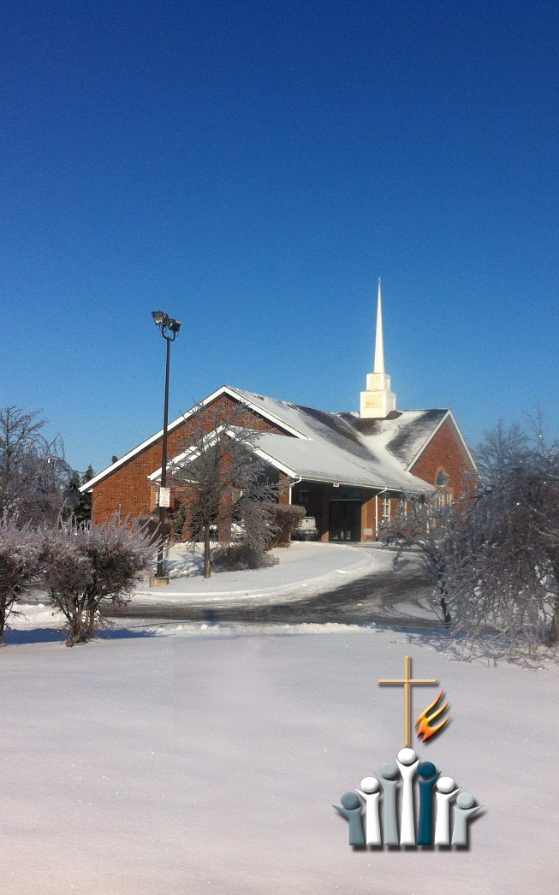

**SAMPLE CHURCH**

2014 Ministry Budget Plan

From the Pastor’s Desk…



Dear FMC family and friends,

The past year, 2013, has been a very interesting and complex year! It will be remembered perhaps as the year of the flood. Or the year you celebrated the birth of a child or grandchild. It may have meant a new job for you, or perhaps losing your old job. It may even have been a year when you lost friends or family.

But regardless of how you remember it, if you are reading this, it means you are still here in the land of the living. That means you have a new year to look forward to!

Yes, we had a flood. And yes, there have been quite a few months of rebuilding in the basement. But looking ahead we have plans to rent our space to another church. We even have ideas that may include forming our own BFMC day-care which will provide employment for people in our community as well as income for the church.

But our highest calling still remains in the three-strand cord of Worship, Connections, and Discipleship and Service. As we anticipate the future for BFMC in Brampton and beyond, join us in praying, working, giving and exalting Christ in 2014.

Blessings from my family to yours…

**Pastor**

***'Where Jesus reigns, salvation comes, healing happens, hope rises and grace abounds'*** *- rc*



Worship...

Worship is at the heart of our life together as a congregation.

When we speak of worship we are talking about the everyday worship life of the people in the church family, as well as the corporate worship gathering on Sundays.

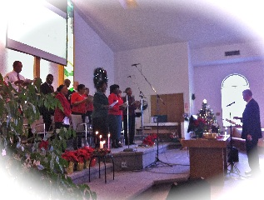When we worship together as a covenant community we praise God with music, hear the proclamation of the Word, celebrate the Lord's Supper, bring our gifts and offerings, and experience fellowship together. There are many facets to conducting our worship services:

⏺ Pastor And Leaders ⏺ Music And Videos

⏺ Worship Leaders ⏺ Audio & Visual Aids

⏺ Musicians And Practice ⏺ Decorations

⏺ Choirs And Cantatas ⏺ Greeters And Ushers

⏺ Communion Preparation ⏺ Writing And Printing

⏺ Fellowship Refreshments ⏺ Facilities Maintenance

Worship at BFMC is supported by the Hospitality and Fellowship Team, as well as the Connections Ministry Team. Together, we try and create an environment where you can experience inspiring worship in a safe, comfortable environment. Your help and ideas are welcome!

**Ministry Cost: $00.**

Connections... **

*‘Therefore if you have any encouragement from being united with Christ, if any comfort from his love, if any common sharing in the Spirit, if any tenderness and compassion, then make my joy complete by being like-minded, having the same love, being one in spirit and of one mind. Do nothing out of selfish ambition or vain conceit. Rather, in humility value others above yourselves,not looking to your own interests but each of you to the interests of the others. In your relationships with one another, have the same mindset as Christ Jesus…’ Philippians 2:1-5*

Connections involve communication, caring and conversation. There are so many ways to connect these days. Social networking, email, telephone, texting and tweeting, all provide opportunities to get to know each other better and stay in touch. The down side however, is that all these modern technological connections make it easier to miss each other and miss opportunities to connect with God and each other on a deeper level.

The Connections Ministry Team will be aiming at helping us relate to God and each other in a way that transforms us, our church, and the community we live in. Connections also place us within reach of each other so that we can effectively fulfill the things of God’s mission in Brampton and beyond.

There are many facets to our connections:

⏺ Pastor And Leaders ⏺ Bulletin

⏺ Pastor's Blog ⏺ BFMC Online Newsletter

⏺ Cards And Notes ⏺ Welcome Package (New)

⏺ Greeters & Ushers ⏺ Announcements

⏺ BFMCFacebook (New) ⏺ Prayer Ministry

**Ministry Cost: $00.**

Discipleship & Service... **

*‘We continually ask God to fill you with the knowledge of his will through all the wisdom and understanding that the Spirit gives, so that you may live a life worthy of the Lord and please him in every way: bearing fruit in every good work, growing in the knowledge of God, being strengthened with all power according to his glorious might so that you may have great endurance and patience, and giving joyful thanks to the Father, who has qualified you to share in the inheritance of his holy people in the kingdom of light.‘ Colossians 1:9-12*

Christians are called to grow as they study God's Word. There is much to learn about God, His grace and His kingdom as we seek to live thankful, service-filled lives. Significant time is spent in helping members grow in their faith. Our children and young people also need to be nurtured in their faith as they mature.

⏺ Pastor And Leaders ⏺ Adult Ministries

⏺ Bible Studies ⏺ Mentoring

⏺ Women's Ministry ⏺ Small Group Ministry

Members of Bramalea Free Methodist Church also provide significant support to several other aspects of our ministry that are not formally part of the General Fund:

⏺ Olive Branch of Hope ⏺ Salvation Army

⏺ World Relief ⏺ Community Basketball

⏺ Home Breakfasts ⏺ Sickle Cell Research

Thank you, for all you do in your community for the cause of Christ!

**Ministry Cost: $00.**

Free Methodist Church Giving... **

*'I pray that you may be active in sharing your faith, so that you will have a full understanding of every good thing we have in Christ.' Philemon 1:6*

MC900441972[1]

Our calling as Christians is to reach others to know Christ. We support this effort both in our community and around the world. Special services and activities help reach our neighbours. Our support of World Relief, International Child Care Ministries, the Free Methodist Giving Streams as well as our own Food Bank and Benevolent Fund continues to reach those in need in our community, across Canada and around the world.

As a **connectional denomination** (meaning that we value the importance of working together in ministry to maximize our commitments and involvements beyond our local church) we use the model of the Biblical tithe to support the greater ‘family’. This is done through our CORE contribution to The Free Methodist Church in Canada.

Our CORE contribution helps our denomination provide

* leadership, quality assurance and accountability for pastoral leaders across the country
* training, resources and strategic planning for churches
* training and development of present and future leaders
* legal, administrative, payroll, medical benefits and pension services for pastors and churches

Because of our support we have been a vital part of :

* Planting churches across Canada *(25% of our denomination is made up of church plants)*
* Reaching the unreached - both in Canada *(14 churches in Quebec which is the largest unreached people group)* and around the world
* Helping both churches and pastors be healthy
* Helped other Free Methodist churches in need
* Helping churches become missional to their communities

**Ministry Cost: $00.   
(10% of our giving)**

Ministry Support & Facilities... **

*'Encourage one another and build each other up, just as in fact you are doing.' 1 Thessalonians 5:11*

**The Hospitality Team, Administrative Services, Prayer Team and Facilities Team** all exist to support the overall ministry of people in and around BFMC Free Methodist Church. They remain constantly alert to the needs of the other leaders in the church and community and commit themselves to helping them achieve their ministry goals.

**The Hospitality Team** strives to continually turn areas of hostility into hospitality. By that, we mean that they help bridge the gap between people with food and fellowship in order to help us build meaningful, lasting relationships. These relationships will be the foundation of our growth and movement in Christ.

**The Prayer Team** continually holds us all up in prayer, fully acknowledging that God is God, and we are not. We move intentionally from an attitude of control, to an attitude of prayer.

**Administrative Services** exist to help in areas of communication, and creating orderly systems that support the chaos of everyday life. Bishop Keith Elford calls it CHAORDIC! God is a God of order, that moves where He wants, and does what He wants. Orderly systems don’t control movement, but rather, help us flex enthusiastically with God’s plans!

**Facilities:** Our church building is the place where worship and ministry happens! It provides us with a place to gather to worship God, fellowship with one another and serves as the centre of activity for a wide variety of ministry needs. We are blessed with volunteers and staff that help keep things clean, well-maintained and running smoothly.

The costs incurred to provide facility support for all the ministries include:

⏺ utilities ⏺ custodial services

⏺ office supplies ⏺ printing/copying

⏺ computer systems ⏺ landscaping

⏺ snow removal ⏺ maintenance & repair

**Ministry Cost: $00.**

**BFMC 2014 Annual Ministry Plan Budget Summary**

**CORE Giving   
10% of Tithes   
& Offerings**

**Support  
18%**

**Worship  
37%**

**Discipleship  
19%**

**Connections  
20%**

**TOTAL: $000,000.**

*Thank you for taking the time to read this Ministry Budget Plan booklet. Our 2014 Ministry Plan anticipates members of BFMC Free Methodist contribute in support of the General Fund and Building Fund.*

*May our offerings be a joyful response to God  
for his goodness and blessings.*

*VISION STATEMENT*

**